SVKM’s NARSEE MONJEE INSTITUTE OF MANAGEMENT STUDIES

# MUKESH PATEL SCHOOL OF TECHNOLOGY MANAGEMENT AND

# ENGINEERING

# A REPORT ON

# Prolific Goalscorers Active between 2000-22

BY:

Akshit Naithani (B208)

Vrishin Jain (B235)

COURSE: B(TECH.) COMPUTER ENGINEERING

Under the supervision of

Prof. Sachin Bhandari

|  |  |
| --- | --- |
| Contents | Page  No |
| Abstract | 3 |
| Introduction | 3 |
| Aim and Objectives | 4 |
| Project Discussion | 4 |
| Conclusions | 39 |
| References | 40 |

**Abstract:**

The project: “Quiz Application” is a collection of number of different types of quizzes

like technical, games, sports, etc. A user can access/play all of the quiz and can attempt any of

the one. There will be limited number of questions and for each correct answer user will get a

credit score. User can see answers as well as can ask a query related to it. There are many quiz

applications available currently on internet. But there are few Which provide better

understanding between users and the application like, providing proper answers, user query

solving, uploading user questions as well as answer to it, etc.

To develop a user friendly quiz application which will contain : Numbers of quiz ,

Answers to every question, Query solving regarding any question, Uploading of user question

and answer, and to improve the knowledge level of users. To develop an application which will

contain solution to the above problems. By this application the user will come to know about

his/her level and can learn additional knowledge. Also by this application a user can expand

his/her knowledge among the world.

The project: “Quiz Application” is a collection of number of different types of quizzes

like technical, games, sports, etc. A user can access/play all of the quiz and can attempt any of

the one. There will be limited number of questions and for each correct answer user will get a

credit score. User can see answers as well as can ask a query related to it. There are many quiz

applications available currently on internet. But there are few Which provide better

understanding between users and the application like, providing proper answers, user query

solving, uploading user questions as well as answer to it, etc.

To develop a user friendly quiz application which will contain : Numbers of quiz ,

Answers to every question, Query solving regarding any question, Uploading of user question

and answer, and to improve the knowledge level of users. To develop an application which will

contain solution to the above problems. By this application the user will come to know about

his/her level and can learn additional knowledge. Also by this application a user can expand

his/her knowledge among the world.

Football is quickly becoming a very popular and complex sport where big clubs are hiring sport analysts to analyse players and provide information whether the player is reliable for the clubs or not.

**Introduction:**

Football matches are won by scoring goals and this program aims to compare the best active goalscorers who were active between 2000 to 2022 and played in the top 5 leagues till the end of the 2021/2022 season. The footballing world has seen many great goalscorers who are well recognized for their talents and the joy they provided to the world. Some of them include players like Diego Maradona, Pele, Gerd Muller, Paolo Maldini, Franz Beckenbauer, Ronaldinho, Marco Van Basten, Andriy Shevchenko, Lionel Messi, Cristiano Ronaldo. The main thing they had in common was the goals they scored and the joy they brought to the fans around the world. A good goalscorer is not only recognized by the goals he scores but how efficient he is in front of the goal and how good he is with the conversion of the chances he gets in a game. This program tends to compare the stats like Shots Per 90, Shot on Target Per 90, Attempted Passes Per Game, Assists, Progressive Passes Per Game (in yards) along with the most basic stat Goals.

**Aim:**

“Our aim is to develop an application for the users in which a user can attempt any number of

quizzes related to his/her choice.”

“To analyse top 10 goal scorers and see what makes them so great and also catch a glimpse into sports analytic”

Attributes Descriptions:

Goals - Total amount of goals scored by the player in their careers

Expected Goals - Amount of goals excepted to be scored by the player in their careers

Assists - Number of passes completed by the player to their team-mate which leads to a goal

Excepted Assists - Amount of assists excepted to be given by the player in their careers

Games Played - Number of games played by the player in their careers

Goals Per Games Played - Average goals scored per match they played

Assists Per Games Played - Average assists given per match they played

Shots Per 90 - Number of shots taken in a match

Shots on target per 90 - Number of shots that were going towards the goal

Shooting Accuracy (in %) - Higher the accuracy, more accurate towards the corners of the goal posts which makes it harder to save

Attempted Passes per game - Passes attempted by the player in a match

Completed Passes Per Game - Passes that were actually received by their team-mates in a match

Progressive Passes Per Game (in yards) - Distance the ball covered towards the opponent's goal when the player passed the ball in a match

Project Discussion:

### Code of the Project:

import pandas as pd

import numpy as np

import matplotlib.pyplot as pt

a = 'yes'

a1 = 'NA'

pd.set_option('display.max_columns',None)

pd.set_option('display.width',None)

while a == 'Yes' or a== 'yes':

print('__'*50)

print(" "*30,"Most Prolific Goal Scorers Of This Decade")

print()

print("1. Analysis Based On Data")

print("2. Data Representation")

print("3. Manipulation Of Data")

print("4. Exit")

print('__'*50)

b = int(input("Enter The Number: "))

z = 'yes'

while z == 'Yes' or z == 'yes':

if b == 1 :

print('\n')

print('__'*50)

print(" "*30,"Analysis Based On Data")

print()

print("1. No. Of Top Records")

print("2. No. Of Bottom Records")

print("3. To Show Number Of Specific Column")

print("4. To Show Multiple Coloumn (Left To Right)")

print("5. To Show Multiple Coloumn (Right To Left)")

print("6. To Show Number Of Specific Row")

print("7. To Show Maximum Of A Column")

print("8. To Show Minimum Of A Column")

print("9. To Show All Records")

print("10. Go Back")

print('__'*50)

d = int(input("Enter The Number: "))

if d == 1 :

f = int(input("How Many Records From The Top ? (Max:10) : "))

if f > 10 :

print("Error! You Entered A Number Greater Than 10")

else :

cdf= pd.read_csv("E:\Backup\C\Python Files\Python Project College\Prolific Scorers Of This Decade.csv",nrows = f)

print(cdf)

z = input("Want To Check Something Else In Analysis Based On Data ?(Yes/No):")

elif d == 2 :

f = int(input("How Many Records From The Bottom ? (Max: 10) : "))

if f > 10 :

print("Error! You Entered A Number Greater Than 10")

else :

cdf= pd.read_csv("E:\Backup\C\Python Files\Python Project College\Prolific Scorers Of This Decade.csv",)

print(cdf.tail(f))

z = input("Want To Check Something Else In Analysis Based On Data ?(Yes/No):")

elif d == 3 :

f = pd.read_csv("E:\Backup\C\Python Files\Python Project College\Prolific Scorers Of This Decade.csv")

g = int(input("How Many Columns Do You Want To Check (Max:14) : "))

h = ['First',"Second","Third",'Fourth','Fifth','Sixth','Seventh','Eighth','Nineth','Tenth','Eleventh','Twelveth','Thirteenth','Fourteenth']

k = []

if g > 14 :

print("Error! You Entered A Number Greater Than 14")

else :

for i in range(0,g) :

print('Enter The ',end = '')

print(h[i],end = '')

m = input(' Column You Want To Read [Column Names: Footballers,Goals,Expected Goals,Assists,Expected Assists,Games Played,Goals Per Games Played,Assists Per Games Played,Shots Per 90,Shot On Target Per 90,Shooting Accuracy(in %),Attempted Passes Per Game,Completed Passes Per Game,Progressive Passes Per Game (in yards)] : ')

k.append(m)

print(f[k])

z = input("Want To Check Something Else In Analysis Based On Data ?(Yes/No):")

elif d == 4 :

f = pd.read_csv("E:\Backup\C\Python Files\Python Project College\Prolific Scorers Of This Decade.csv")

g = int(input("How Many Columns From Left Do You Want To Check (Max:14) : "))

h = ['Footballers','Goals','Expected Goals','Assists','Expected Assists','Games Played','Goals Per Games Played','Assists Per Games Played','Shots Per 90','Shot On Target Per 90','Shooting Accuracy(in %)','Attempted Passes Per Game','Completed Passes Per Game','Progressive Passes Per Game (in yards)']

k = []

if g > 14 :

print("Error! You Entered A Number Greater Than 14")

else :

for i in range(0,g) :

k.append(h[i])

print(f[k])

z = input("Want To Check Something Else ?(Yes/No):")

elif d == 5 :

f = pd.read_csv("E:\Backup\C\Python Files\Python Project College\Prolific Scorers Of This Decade.csv")

g = int(input("How Many Columns From Left Do You Want To Check (Max:14) : "))

h = ['Progressive Passes Per Game (in yards)','Completed Passes Per Game','Attempted Passes Per Game','Shooting Accuracy(in %)','Shot On Target Per 90','Shots Per 90','Assists Per Games Played','Goals Per Games Played','Games Played','Expected Assists','Assists','Expected Goals','Goals']

k = []

if g > 14 :

print("Error! You Entered A Number Greater Than 14")

else :

for i in range(0,g) :

k.append(h[i])

print(f[k])

z = input("Want To Check Something Else In Analysis Based On Data ?(Yes/No):")

elif d == 6 :

p = []

c = []

q = []

e = []

f = []

g = []

p1 = []

c1 = []

q1 = []

e1 = []

f1 = []

g1 = []

p11 = []

c11 = []

h = ['First',"Second","Third",'Fourth','Fifth','Sixth','Seventh','Eighth','Nineth','Tenth','Eleventh','Twelveth','Thirteenth','Fourteenth']

o = 0

p = []

q = []

for i in range(1,11):

for j in range(1,11):

r = list(pd.read_csv("E:\Backup\C\Python Files\Python Project College\Prolific Scorers Of This Decade.csv",skiprows= i, nrows= j))

p.append(r[0])

c.append(r[1])

q.append(r[2])

e.append(r[3])

f.append(r[4])

g.append(r[5])

p1.append(r[6])

c1.append(r[7])

q1.append(r[8])

e1.append(r[9])

f1.append(r[10])

g1.append(r[11])

p11.append(r[12])

c11.append(r[13])

k = int(input("How Many Rows You Want To Check ?(Max 10): "))

print("Footballer = ")

for l in range(0,k):

print('Enter The ',end = '')

print(h[l],end = '')

m = input(' Row You Want To Read (Names: Ronaldo, Messi, Aguero, Huntelaar, Cavani, Higuain, Suarez, Lewandowski, Ibrahimovic, Rooney)[Case Sensitive]: ')

for n in range(1,11):

if m == p[o] :

print(m,' = ',[c[o],q[o],e[o],f[o],g[o],p1[o],c1[o],q1[o],e1[o],f1[o],g1[o],p11[o],c11[o]])

o = o + 1

o = 0

z = input("Want To Check Something Else In Analysis Based On Data ?(Yes/No):")

elif d == 7 :

r = input("Enter The Column You Want The Maximum Of (Column Names: Goals, Expected Goals, Assists, Expected Assists, Games Played, Goals Per Games Played, Assists Per Games Played, Shots Per 90,Shot On Target Per 90, Shooting Accuracy(in %), Attempted Passes Per Game, Completed Passes Per Game, Progressive Passes Per Game(in yards))[Case Sensitive]: ")

cdf= pd.read_csv("E:\Backup\C\Python Files\Python Project College\Prolific Scorers Of This Decade.csv", header = None, skiprows = 1,names = ['Footballers','Goals','Expected Goals','Assists','Expected Assists','Games Played','Goals Per Games Played','Assists Per Games Played','Shots Per 90','Shot On Target Per 90','Shooting Accuracy(in %)','Attempted Passes Per Game','Completed Passes Per Game','Progressive Passes Per Game (in yards)'])

print(cdf)

if r == 'Goals' :

print("Maximum Goals Scored Is ",cdf['Goals'].max())

elif r == 'Expected Goals' :

print("Maximum Expected Goals Is ",cdf['Expected Goals'].max())

elif r == 'Assists' :

print("Maximum Assists Scored Is ",cdf['Assists'].max())

elif r == 'Expected Assists' :

print("Maximum Expected Assists Is ",cdf['Expected Assists'].max())

elif r == 'Games Played' :

print("Maximum Games Played Is ",cdf['Games Played'].max())

elif r == 'Goals Per Games Played' :

print("Maximum Is ",cdf['Goals Per Games Played'].max())

elif r == 'Assists Per Games Played' :

print("Maximum Games Played Is ",cdf['Assists Per Games Played'].max())

elif r == 'Shots Per 90' :

print("Maximum Goals Per Games Played Is ",cdf['Shots Per 90'].max())

elif r == 'Shot On Target Per 90' :

print("Maximum Shot On Target Per Match Is ",cdf['Shot On Target Per 90'].max())

elif r == 'Shooting Accuracy(in %)' or r == 'Shooting Accuracy' :

print("Maximum Shot Accuracy Per Match Is ",cdf['Shooting Accuracy (in %)'].max())

elif r == 'Attempted Passes Per Game':

print("Maximum Shot Accuracy Per Match Is ",cdf['Attempted Passes Per Game'].max())

elif r == 'Completed Passes Per Game':

print("Maximum Shot Accuracy Per Match Is ",cdf['Completed Passes Per Game'].max())

elif r == 'Progressive Passes Per Game (in yards)' or r == 'Progressive Passes Per Game':

print("Maximum Shot Accuracy Per Match Is ",cdf['Progressive Passes Per Game (in yards)'].max())

else :

print("You Entered The Wrong Value")

z = input("Want To Check Something Else In Analysis Based On Data ?(Yes/No):")

elif d == 8 :

r = input("Enter The Column You Want The Minimum Of (Column Names: Footballers,Goals,Expected Goals,Assists,Expected Assists,Games Played,Goals Per Games Played,Assists Per Games Played,Shots Per 90,Shot On Target Per 90,Shooting Accuracy(in %),Attempted Passes Per Game,Completed Passes Per Game,Progressive Passes Per Game (in yards))[Case Sensitive]: ")

cdf= pd.read_csv("E:\Backup\C\Python Files\Python Project College\Prolific Scorers Of This Decade.csv", header = None, skiprows = 1,names = ['Footballers','Goals','Expected Goals','Assists','Expected Assists','Games Played','Goals Per Games Played','Assists Per Games Played','Shots Per 90','Shot On Target Per 90','Shooting Accuracy(in %)','Attempted Passes Per Game','Completed Passes Per Game','Progressive Passes Per Game (in yards)'])

print(cdf)

if r == 'Goals' :

print("Minimum Goals Scored Is ",cdf['Goals'].min())

elif r == 'Expected Goals' :

print("Minimum Expected Goals Is ",cdf['Expected Goals'].min())

elif r == 'Assists' :

print("Minimum Assists Scored Is ",cdf['Assists'].min())

elif r == 'Expected Assists' :

print("Minimum Expected Assists Is ",cdf['Expected Assists'].min())

elif r == 'Games Played' :

print("Minimum Games Played Is ",cdf['Games Played'].min())

elif r == 'Goals Per Games Played' :

print("Minimum Is ",cdf['Goals Per Games Played'].min())

elif r == 'Assists Per Games Played' :

print("Minimum Games Played Is ",cdf['Assists Per Games Played'].min())

elif r == 'Shots Per 90' :

print("Minimum Goals Per Games Played Is ",cdf['Shots Per 90'].min())

elif r == 'Shot On Target Per 90' :

print("Minimum Shot On Target Per Match Is ",cdf['Shot On Target Per 90'].min())

elif r == 'Shooting Accuracy(in %)' or r == 'Shooting Accuracy' :

print("Minimum Shot Accuracy Per Match Is ",cdf['Shooting Accuracy (in %)'].min())

elif r == 'Attempted Passes Per Game':

print("Minimum Shot Accuracy Per Match Is ",cdf['Attempted Passes Per Game'].min())

elif r == 'Completed Passes Per Game':

print("Minimum Shot Accuracy Per Match Is ",cdf['Completed Passes Per Game'].min())

elif r == 'Progressive Passes Per Game (in yards)' or r == 'Progressive Passes Per Game':

print("Minimum Shot Accuracy Per Match Is ",cdf['Progressive Passes Per Game (in yards)'].min())

else :

print("You Entered The Wrong Value")

z = input("Want To Check Something Else In Analysis Based On Data ?(Yes/No):")

elif d == 9 :

cdf= pd.read_csv("E:\Backup\C\Python Files\Python Project College\Prolific Scorers Of This Decade.csv")

print(cdf)

z = input("Want To Check Something Else In Analysis Based On Data ?(Yes/No):")

elif d == 10 :

print()

break

else :

print("*"*100)

print("Oops... I Think You Entered The Wrong Value")

print("*"*100)

elif b == 2 :

while a1 == 'NA':

if a1 == 'NA':

print('\n')

print('__'*50)

a2 = input("Apply Anti Color-Blind Colors On Graphs ???(Yes/No) : ")

print()

if a2 == 'yes' or a2 == 'YES':

w = input("Red-Green/Blue-Yellow(RG/BY): ")

a1 = 'A'

break

elif a2 == 'no' or a2 == 'No' :

w = 'else'

a1 = 'A'

break

else :

print("Oops! You Entered Something Wrong")

print('\n')

print('__'*50)

print(" "*30,"Data Representation")

print()

print("1. Line Chart Depicting Shots On Target Per 90")

print("2. Pie Chart Depicting Shot Accuracy")

print("3. Bar Chart Depicting Goals Scored")

print("4. Line Depicting Goals Per Games Played")

print("5. Bar Chart Depicting Assists")

print("6. Bar Chart Depicting Expected Assists")

print("7. Line Chart Depicting Assists Per Games Played")

print("8. Bar Chart Depicting Shots Per 90")

print("9. Bar Chart Depicting Attempted Pass Per 90")

print("10. Bar Chart Depicting Completed Pass Per 90")

print("11. Barh Chart Depicting Progessive Passes Per 90")

print("12. Bar Chart Depicting Expected Goals")

print("13. Bar Chart Depicting Games Played")

print('14. Go Back')

print('__'*50)

c = int(input("Enter The Number: "))

if c == 1 :

g = []

h = []

for i in range(1,11):

for j in range(1,11):

f = list(pd.read_csv("E:\Backup\C\Python Files\Python Project College\Prolific Scorers Of This Decade.csv",skiprows= i, nrows= j))

d = g.append(float(f[9]))

e = h.append(f[0])

X = np.arange(10)

if w == 'BY':

pt.plot(X,g,color='red')

elif w == 'RG':

pt.plot(X,g,color='blue')

else :

pt.plot(X,g,color='red')

pt.xticks(X,h)

pt.ylabel("Shots On Target Per 90")

pt.xlabel("Footballers")

pt.title("Shots On Target By Footballer P90")

pt.show()

z = input("Want To Check Something Else In Data Representation ?(Yes/No):")

elif c == 2 :

g = []

h = []

if w == 'BY':

col = ['darkgreen','grey','maroon','violet','darkred','green','pink','silver','red','beige']

elif w == 'RG':

col = ['blue','cyan','gold','violet','darkblue','grey','orange','silver','beige','yellow']

else :

col = ['blue','cyan','gold','violet','darkblue','green','pink','silver','red','yellow']

for i in range(1,11):

for j in range(1,11):

f = list(pd.read_csv("E:\Backup\C\Python Files\Python Project College\Prolific Scorers Of This Decade.csv",skiprows= i, nrows= j))

d = g.append(float(f[10]))

e = h.append(f[0])

X = np.arange(10)

pt.pie(g,labels= h,colors= col,autopct= "%5.3f%%")

pt.axis("equal")

pt.title("Shot Accuary (in %)")

pt.show()

z = input("Want To Check Something Else In Data Representation ?(Yes/No):")

elif c == 3 :

g = []

h = []

if w == 'BY':

col = ['darkgreen','grey','maroon','violet','darkred','green','pink','silver','red','beige']

elif w == 'RG':

col = ['blue','cyan','gold','violet','darkblue','grey','orange','silver','beige','yellow']

else :

col = ['blue','cyan','gold','violet','darkblue','green','pink','silver','red','yellow']

for i in range(1,11):

for j in range(1,11):

f = list(pd.read_csv("E:\Backup\C\Python Files\Python Project College\Prolific Scorers Of This Decade.csv",skiprows= i, nrows= j))

d = g.append(float(f[1]))

e = h.append(f[0])

X = np.arange(10)

pt.bar(h,g,color = col)

pt.title("Goals Scored In Their Carrers(Till 2021-22 Season)")

pt.ylabel('Goals')

pt.xlabel('Footballers')

pt.show()

z = input("Want To Check Something Else In Data Representation ?(Yes/No):")

elif c == 4 :

g = []

h = []

for i in range(1,11):

for j in range(1,11):

f = list(pd.read_csv("E:\Backup\C\Python Files\Python Project College\Prolific Scorers Of This Decade.csv",skiprows= i, nrows= j))

d = g.append(float(f[6]))

e = h.append(f[0])

X = np.arange(10)

if w == 'BY':

pt.plot(h,g,color='red')

elif w == 'RG':

pt.plot(h,g,color='blue')

else :

pt.plot(h,g,color='red')

pt.title("Total Goals Per Total Games Played")

pt.ylabel('Goals Per Games Played')

pt.xlabel('Footballers')

pt.show()

z = input("Want To Check Something Else In Data Representation ?(Yes/No):")

elif c == 5 :

g = []

h = []

if w == 'BY':

col = ['darkgreen','grey','maroon','violet','darkred','green','pink','silver','red','beige']

elif w == 'RG':

col = ['blue','cyan','gold','violet','darkblue','grey','orange','silver','beige','yellow']

else :

col = ['blue','cyan','gold','violet','darkblue','green','pink','silver','red','yellow']

for i in range(1,11):

for j in range(1,11):

f = list(pd.read_csv("E:\Backup\C\Python Files\Python Project College\Prolific Scorers Of This Decade.csv",skiprows= i, nrows= j))

d = g.append(float(f[3]))

e = h.append(f[0])

X = np.arange(10)

pt.bar(h,g,color = col)

pt.title("Assists Given In Their Carrers(Till 2021-22 Season)")

pt.ylabel('Assists')

pt.xlabel('Footballers')

pt.show()

z = input("Want To Check Something Else In Data Representation ?(Yes/No):")

elif c == 6 :

g = []

h = []

if w == 'BY':

col = ['darkgreen','grey','maroon','violet','darkred','green','pink','silver','red','beige']

elif w == 'RG':

col = ['blue','cyan','gold','violet','darkblue','grey','orange','silver','beige','yellow']

else :

col = ['blue','cyan','gold','violet','darkblue','green','pink','silver','red','yellow']

for i in range(1,11):

for j in range(1,11):

f = list(pd.read_csv("E:\Backup\C\Python Files\Python Project College\Prolific Scorers Of This Decade.csv",skiprows= i, nrows= j))

d = g.append(float(f[4]))

e = h.append(f[0])

X = np.arange(10)

pt.bar(h,g,color = col)

pt.title("Expected Assists Of Their Carrers(Till 2021-22 Season)")

pt.ylabel('Expected Assists')

pt.xlabel('Footballers')

pt.show()

z = input("Want To Check Something Else In Data Representation ?(Yes/No):")

elif c == 7 :

g = []

h = []

for i in range(1,11):

for j in range(1,11):

f = list(pd.read_csv("E:\Backup\C\Python Files\Python Project College\Prolific Scorers Of This Decade.csv",skiprows= i, nrows= j))

d = g.append(float(f[7]))

e = h.append(f[0])

X = np.arange(10)

if w == 'BY':

pt.plot(h,g,color='red')

elif w == 'RG':

pt.plot(h,g,color='blue')

else :

pt.plot(h,g,color='red')

pt.title("Assists Per 90")

pt.ylabel('Assists Per 90')

pt.xlabel('Footballers')

pt.show()

z = input("Want To Check Something Else In Data Representation ?(Yes/No):")

elif c == 8 :

g = []

h = []

if w == 'BY':

col = ['darkgreen','grey','maroon','violet','darkred','green','pink','silver','red','beige']

elif w == 'RG':

col = ['blue','cyan','gold','violet','darkblue','grey','orange','silver','beige','yellow']

else :

col = ['blue','cyan','gold','violet','darkblue','green','pink','silver','red','yellow']

for i in range(1,11):

for j in range(1,11):

f = list(pd.read_csv("E:\Backup\C\Python Files\Python Project College\Prolific Scorers Of This Decade.csv",skiprows= i, nrows= j))

d = g.append(float(f[8]))

e = h.append(f[0])

X = np.arange(10)

pt.bar(h,g,color = col)

pt.title("Shots Taken Per 90")

pt.ylabel('Shots Per 90')

pt.xlabel('Footballers')

pt.show()

z = input("Want To Check Something Else In Data Representation ?(Yes/No):")

elif c == 9 :

g = []

h = []

if w == 'BY':

col = ['darkgreen','grey','maroon','violet','darkred','green','pink','silver','red','beige']

elif w == 'RG':

col = ['blue','cyan','gold','violet','darkblue','grey','orange','silver','beige','yellow']

else :

col = ['blue','cyan','gold','violet','darkblue','green','pink','silver','red','yellow']

for i in range(1,11):

for j in range(1,11):

f = list(pd.read_csv("E:\Backup\C\Python Files\Python Project College\Prolific Scorers Of This Decade.csv",skiprows= i, nrows= j))

d = g.append(float(f[11]))

e = h.append(f[0])

X = np.arange(10)

pt.bar(h,g,color = col)

pt.title("Attempted Passes Per 90")

pt.ylabel('Attempted Passes P90')

pt.xlabel('Footballers')

pt.show()

z = input("Want To Check Something Else In Data Representation ?(Yes/No):")

elif c == 10 :

g = []

h = []

if w == 'BY':

col = ['darkgreen','grey','maroon','violet','darkred','green','pink','silver','red','beige']

elif w == 'RG':

col = ['blue','cyan','gold','violet','darkblue','grey','orange','silver','beige','yellow']

else :

col = ['blue','cyan','gold','violet','darkblue','green','pink','silver','red','yellow']

for i in range(1,11):

for j in range(1,11):

f = list(pd.read_csv("E:\Backup\C\Python Files\Python Project College\Prolific Scorers Of This Decade.csv",skiprows= i, nrows= j))

d = g.append(float(f[12]))

e = h.append(f[0])

X = np.arange(10)

pt.bar(h,g,color = col)

pt.title("Completed Passes Per 90")

pt.ylabel('Completed Passes P90')

pt.xlabel('Footballers')

pt.show()

z = input("Want To Check Something Else In Data Representation ?(Yes/No):")

elif c == 11 :

g = []

h = []

if w == 'BY':

col = ['darkgreen','grey','maroon','violet','darkred','green','pink','silver','red','beige']

elif w == 'RG':

col = ['blue','cyan','gold','violet','darkblue','grey','orange','silver','beige','yellow']

else :

col = ['blue','cyan','gold','violet','darkblue','green','pink','silver','red','yellow']

for i in range(1,11):

for j in range(1,11):

f = list(pd.read_csv("E:\Backup\C\Python Files\Python Project College\Prolific Scorers Of This Decade.csv",skiprows= i, nrows= j))

d = g.append(float(f[13]))

e = h.append(f[0])

X = np.arange(10)

pt.barh(h,g,color = col)

pt.title("Prgressive Passes Per 90 (in Yards)")

pt.ylabel('Progressive Pass P90')

pt.xlabel('Footballers')

pt.show()

z = input("Want To Check Something Else In Data Representation ?(Yes/No):")

elif c == 12 :

g = []

h = []

if w == 'BY':

col = ['darkgreen','grey','maroon','violet','darkred','green','pink','silver','red','beige']

elif w == 'RG':

col = ['blue','cyan','gold','violet','darkblue','grey','orange','silver','beige','yellow']

else :

col = ['blue','cyan','gold','violet','darkblue','green','pink','silver','red','yellow']

for i in range(1,11):

for j in range(1,11):

f = list(pd.read_csv("E:\Backup\C\Python Files\Python Project College\Prolific Scorers Of This Decade.csv",skiprows= i, nrows= j))

d = g.append(float(f[2]))

e = h.append(f[0])

X = np.arange(10)

pt.bar(h,g,color = col)

pt.title("Expected Carrer Goals")

pt.ylabel('Expected Goals')

pt.xlabel('Footballers')

pt.show()

z = input("Want To Check Something Else In Data Representation ?(Yes/No):")

elif c == 13 :

g = []

h = []

if w == 'BY':

col = ['darkgreen','grey','maroon','violet','darkred','green','pink','silver','red','beige']

elif w == 'RG':

col = ['blue','cyan','gold','violet','darkblue','grey','orange','silver','beige','yellow']

else :

col = ['blue','cyan','gold','violet','darkblue','green','pink','silver','red','yellow']

for i in range(1,11):

for j in range(1,11):

f = list(pd.read_csv("E:\Backup\C\Python Files\Python Project College\Prolific Scorers Of This Decade.csv",skiprows= i, nrows= j))

d = g.append(float(f[5]))

e = h.append(f[0])

X = np.arange(10)

pt.bar(h,g,color = col)

pt.title("Games Played In Their Carrers(Till 2021-22 Season)")

pt.ylabel('Games Played')

pt.xlabel('Footballers')

pt.show()

z = input("Want To Check Something Else In Data Representation ?(Yes/No):")

elif c == 14 :

print()

break

else :

print("*"*100)

print("Oops... I Think You Entered The Wrong Value. Try Again")

print("*"*100)

elif b == 3:

print('\n')

print('__'*50)

print(' '* 25,'Manipulation')

print()

print("1. Add A Column")

print("2. Remove A Column")

print("3. Add A Row")

print('4. Remove A Row')

print('5. Go Back')

print('__'*50)

c = int(input("Enter The Number: "))

if c == 1 :

cdf= pd.read_csv("E:\Backup\C\Python Files\Python Project College\Prolific Scorers Of This Decade.csv")

print(cdf)

e = pd.Series([],dtype = 'str')

g = input("Enter The Column Name: ")

h = ['First','Second','Third','Fourth','Fifith','Sixth','Seventh','Eighth','Nineth','Tenth']

for i in range(len(cdf)):

print("Enter The ",end = '')

print(h[i],end ='')

f = input(" Value: ")

e[i] = f

j = int(input("Enter The Position Where You Want To Insert The Column (0-14)[0 Meaning Farthest Left]: "))

cdf.insert(j,g,e)

print(cdf)

z = input("Want To Manipulate Something Else ?(Yes/No):")

elif c == 2 :

cdf= pd.read_csv("E:\Backup\C\Python Files\Python Project College\Prolific Scorers Of This Decade.csv")

print(cdf)

e = int(input("How Many Columns You Want To Delete (Max : 14): "))

g = ['First','Second','Third','Fourth','Fifith','Sixth','Seventh','Eighth','Nineth','Tenth']

for i in range(e):

print('Enter The ',end = '')

print(g[i],end = '')

f = input(' [Column Names: Footballers,Goals,Expected Goals,Assists,Expected Assists,Games Played,Goals Per Games Played,Assists Per Games Played,Shots Per 90,Shot On Target Per 90,Shooting Accuracy(in %),Attempted Passes Per Game,Completed Passes Per Game,Progressive Passes Per Game (in yards)](Case Sensitive): ')

cdf.drop([f],axis = 1, inplace = True)

print(cdf)

z = input("Want To Manipulate Something Else ?(Yes/No):")

elif c == 3 :

cdf = pd.read_csv("E:\Backup\C\Python Files\Python Project College\Prolific Scorers Of This Decade.csv")

print(cdf)

e = pd.Series([],dtype = 'str')

g = int(input("Enter How Many Rows: "))

h = ['Footballers','Goals','Expected Goals','Assists','Expected Assists','Games Played','Goals Per Games Played','Assists Per Games Played','Shots Per 90','Shot On Target Per 90','Shooting Accuracy(in %)','Attempted Passes Per Game','Completed Passes Per Game','Progressive Passes Per Game (in yards)']

l = []

for i in range(g):

for j in range(0,6):

print("Enter The ",end = '')

print(h[j],end ='')

f = input(" : ")

l.append(f)

m = cdf.append({h[0] : l[0], h[1] : l[1], h[2] : l[2], h[3] : l[3], h[4] : l[4], h[5] : l[5]},ignore_index= True,verify_integrity=False)

l = []

print(m)

z = input("Want To Manipulate Something Else ?(Yes/No):")

elif c == 4 :

cdf= pd.read_csv("E:\Backup\C\Python Files\Python Project College\Prolific Scorers Of This Decade.csv",index_col ="Footballers")

print(cdf)

e = int(input("How Many Rows You Want To Delete (Max : 10): "))

g = ['First','Second','Third','Fourth','Fifith','Sixth','Seventh','Eighth','Nineth','Tenth']

for i in range(e):

print('Enter The ',end = '')

print(g[i],end = '')

f = input(" Row (Footballer's Name [Case Sensitive]): ")

cdf.drop([f],axis = 0, inplace = True)

print(cdf)

z = input("Want To Manipulate Something Else ?(Yes/No):")

elif c == 5 :

print()

break

else :

print("*"*100)

print("Oops... I Think You Entered The Wrong Value. Try Again")

print("*"*100)

elif b > 4 :

print('\n')

print("*"*100)

print("Oops... I Think You Entered The Wrong Value. Try Again")

print("*"*100)

print('\n')

a = input("Want To Try Again ?(Yes/No):")

break

elif b == 4:

print("Goodbye. Thank You For Checking It Out")

break

if b == 4:

break

print("Goodbye. Thank You For Checking It Out"

### Output of the Project :

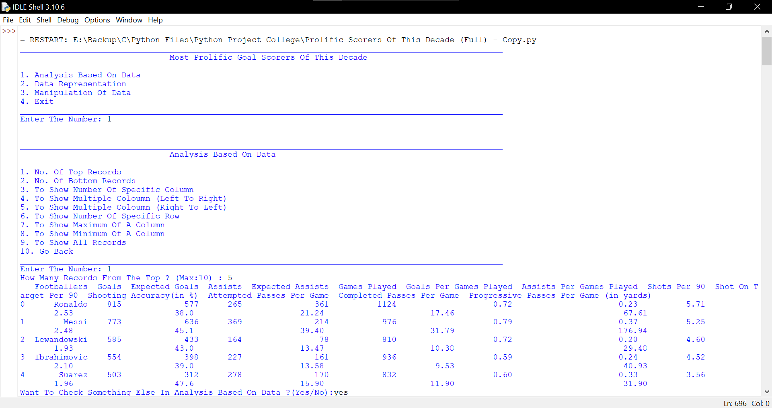

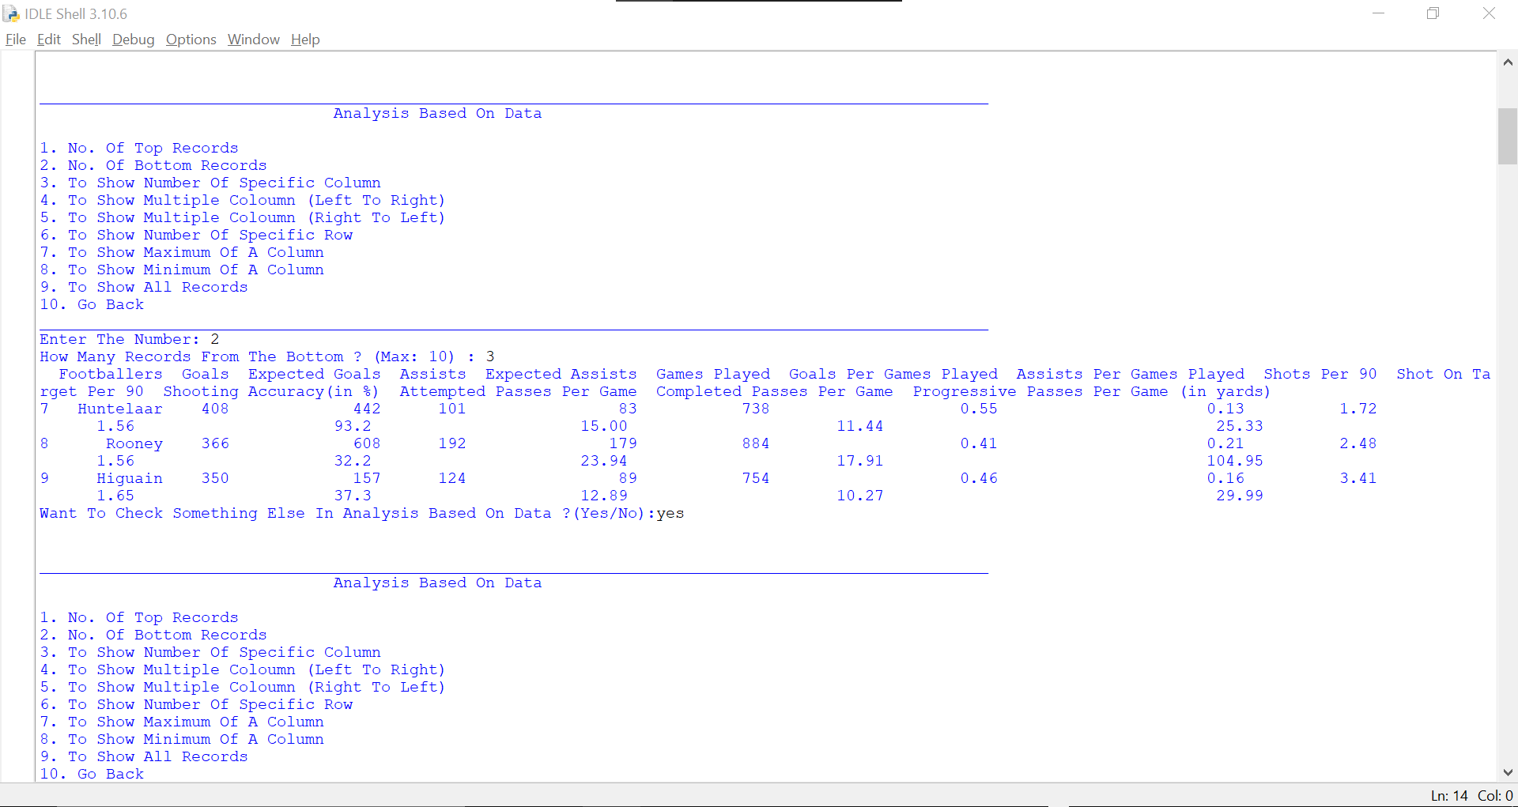

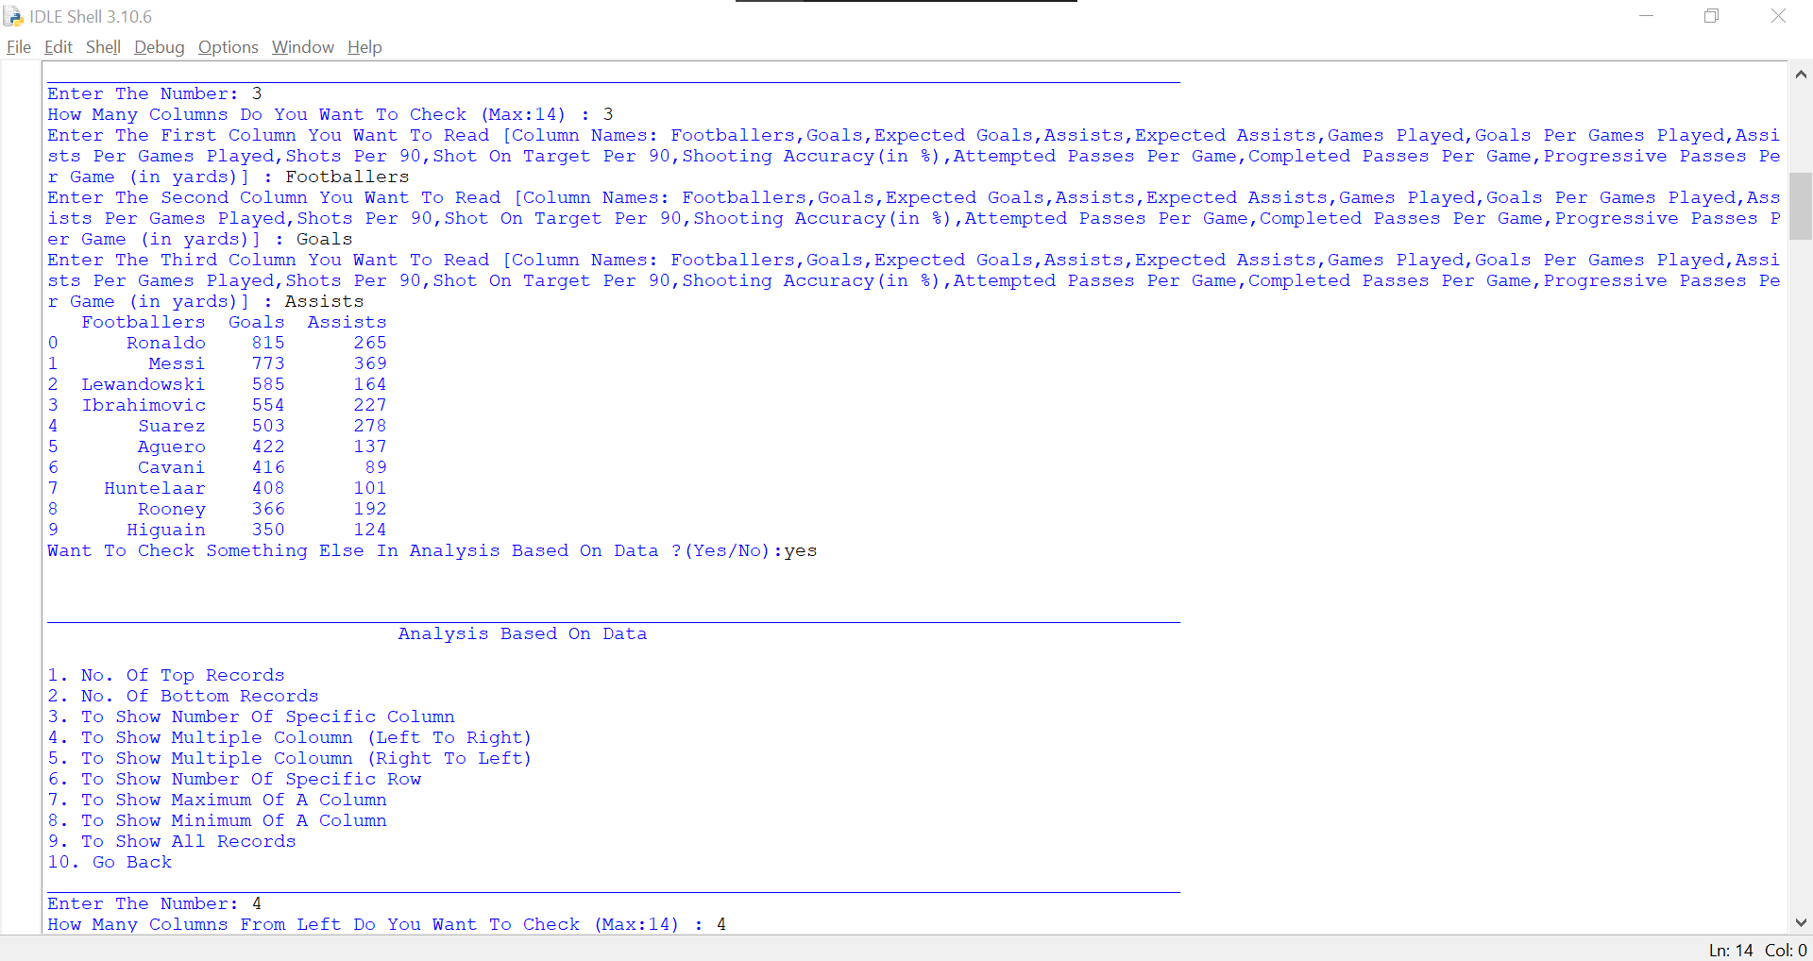

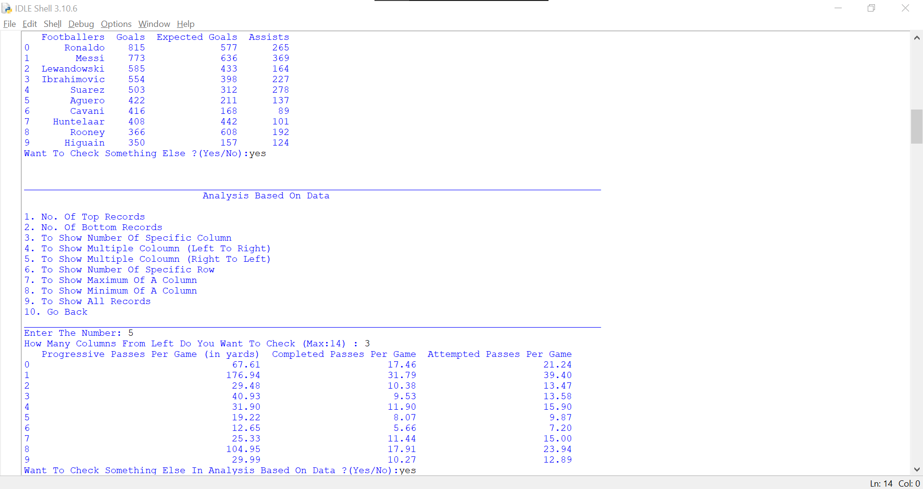

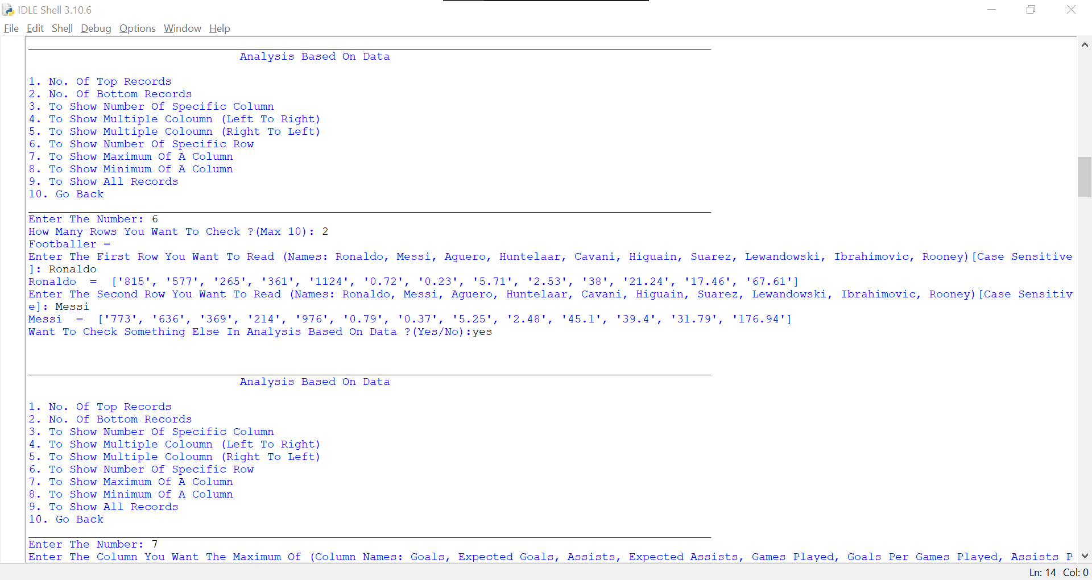

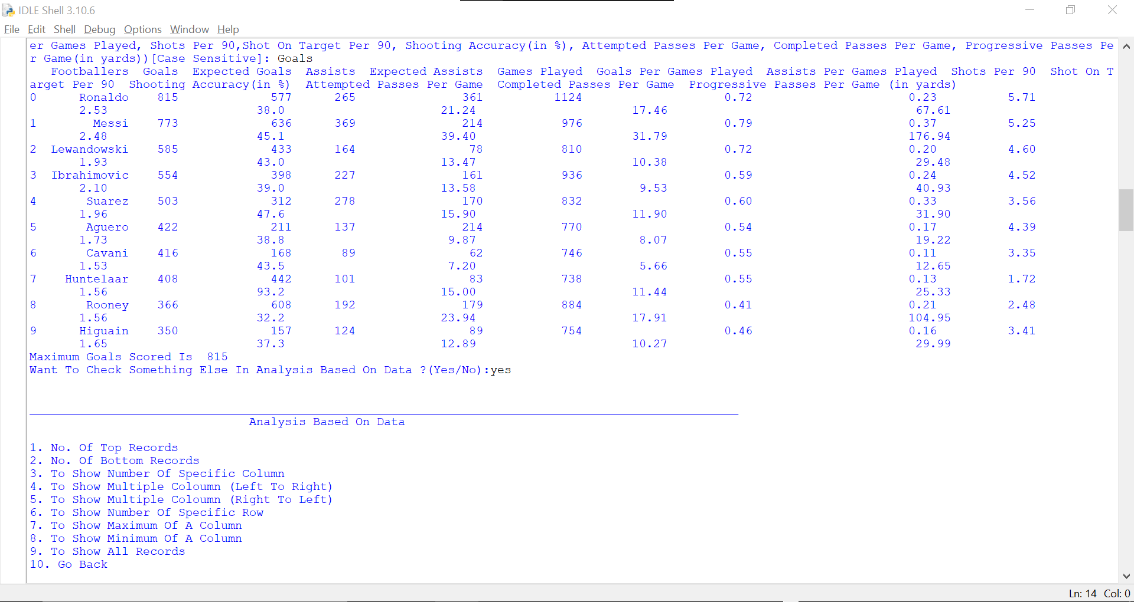

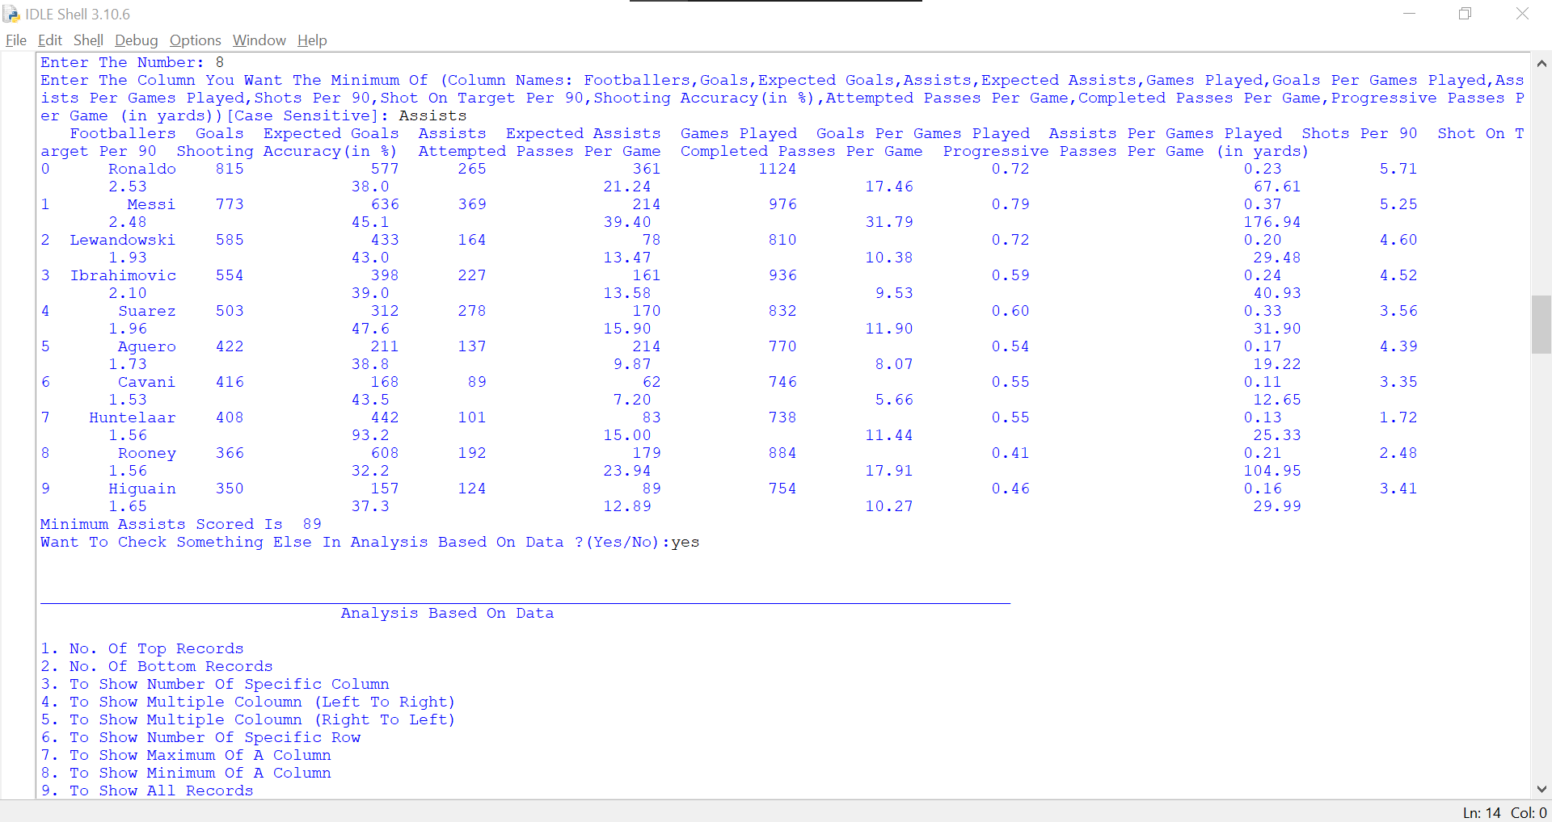

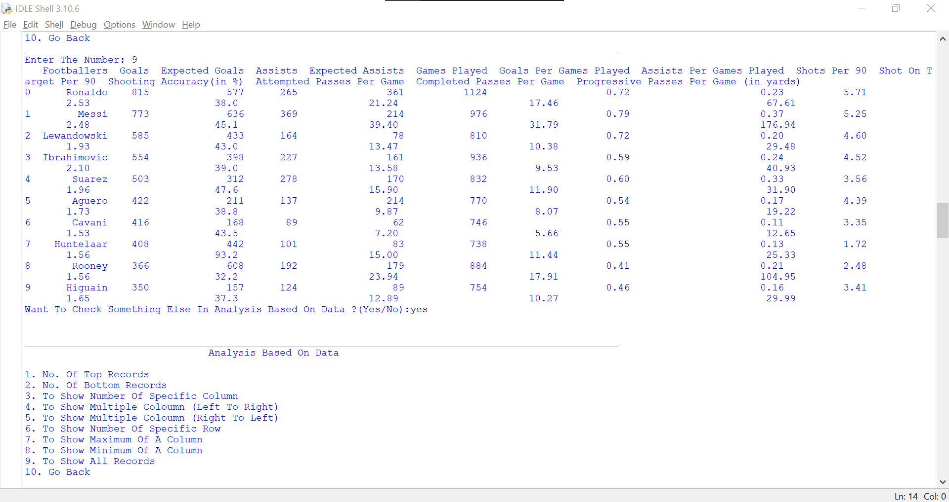

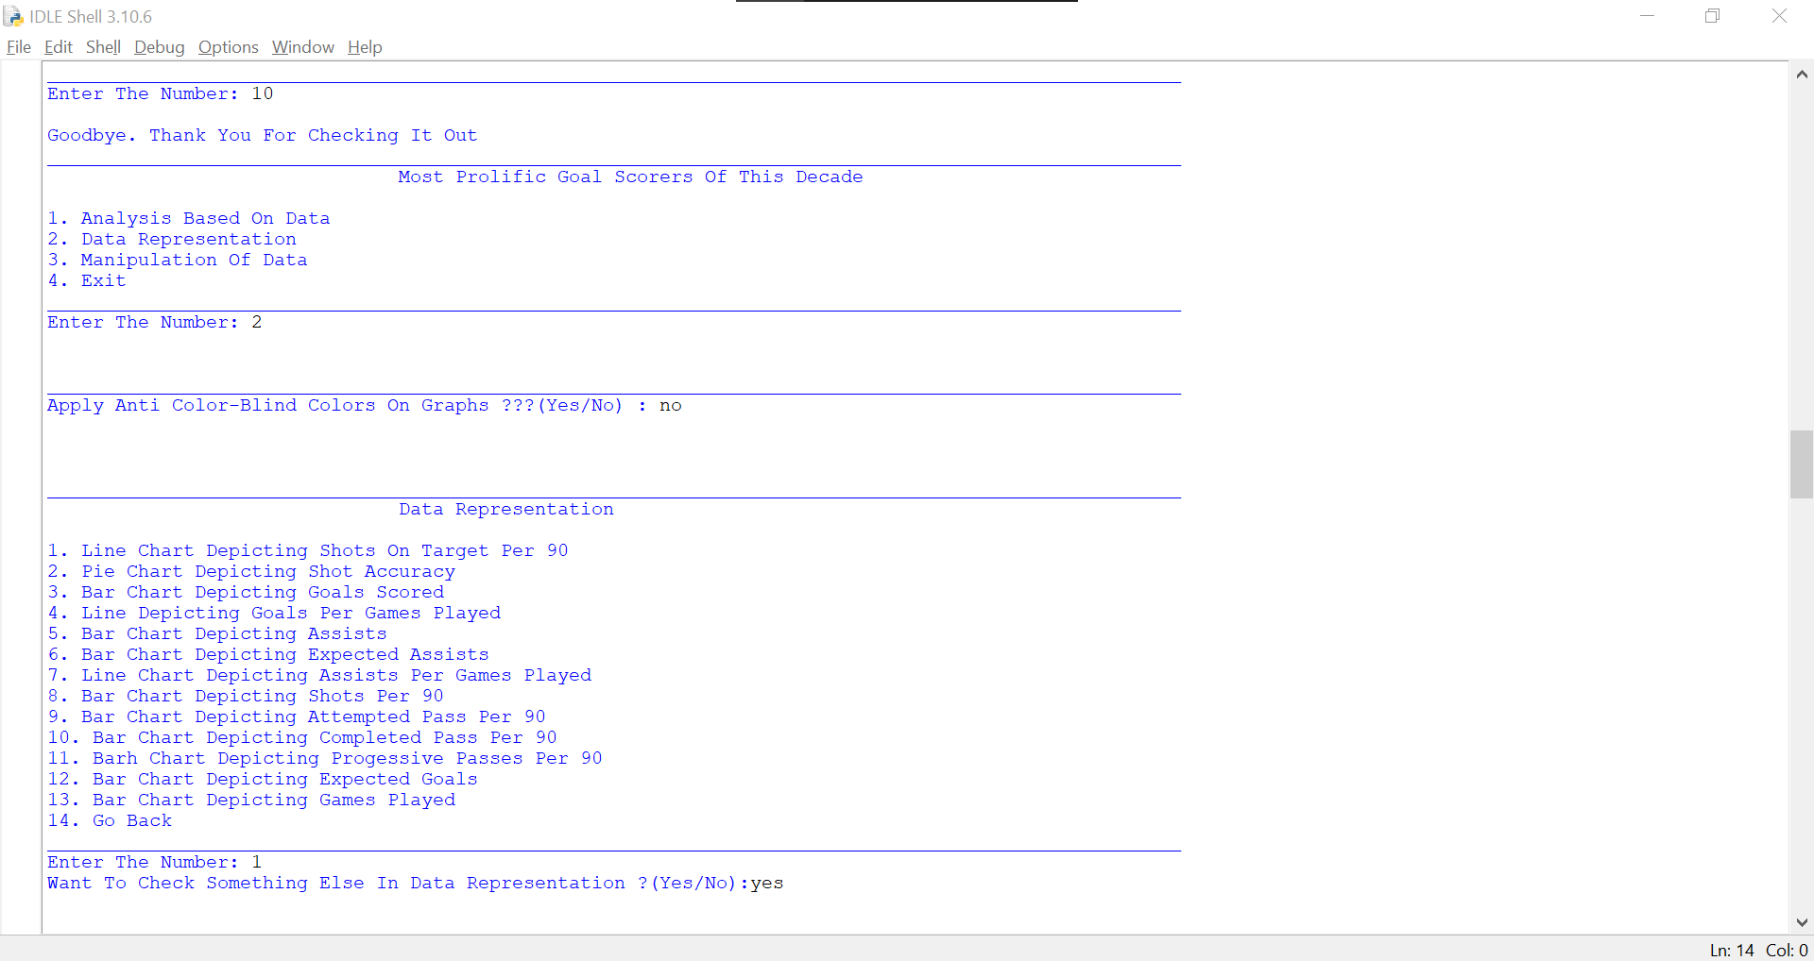

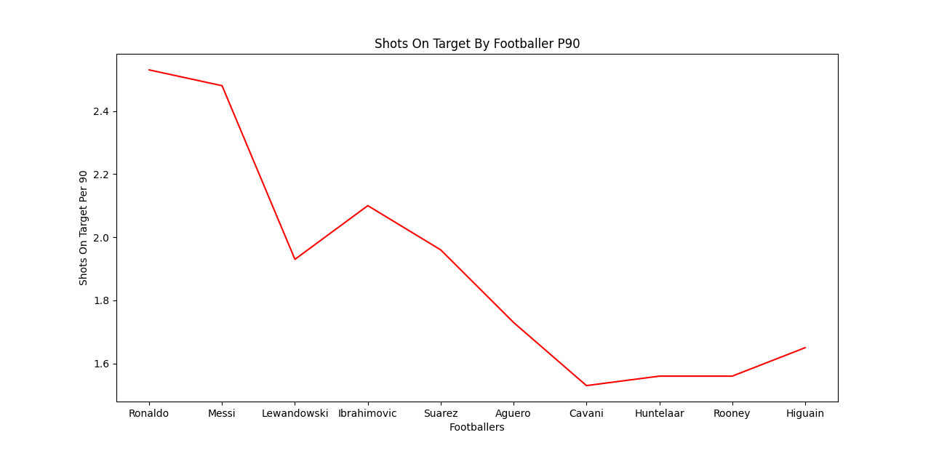

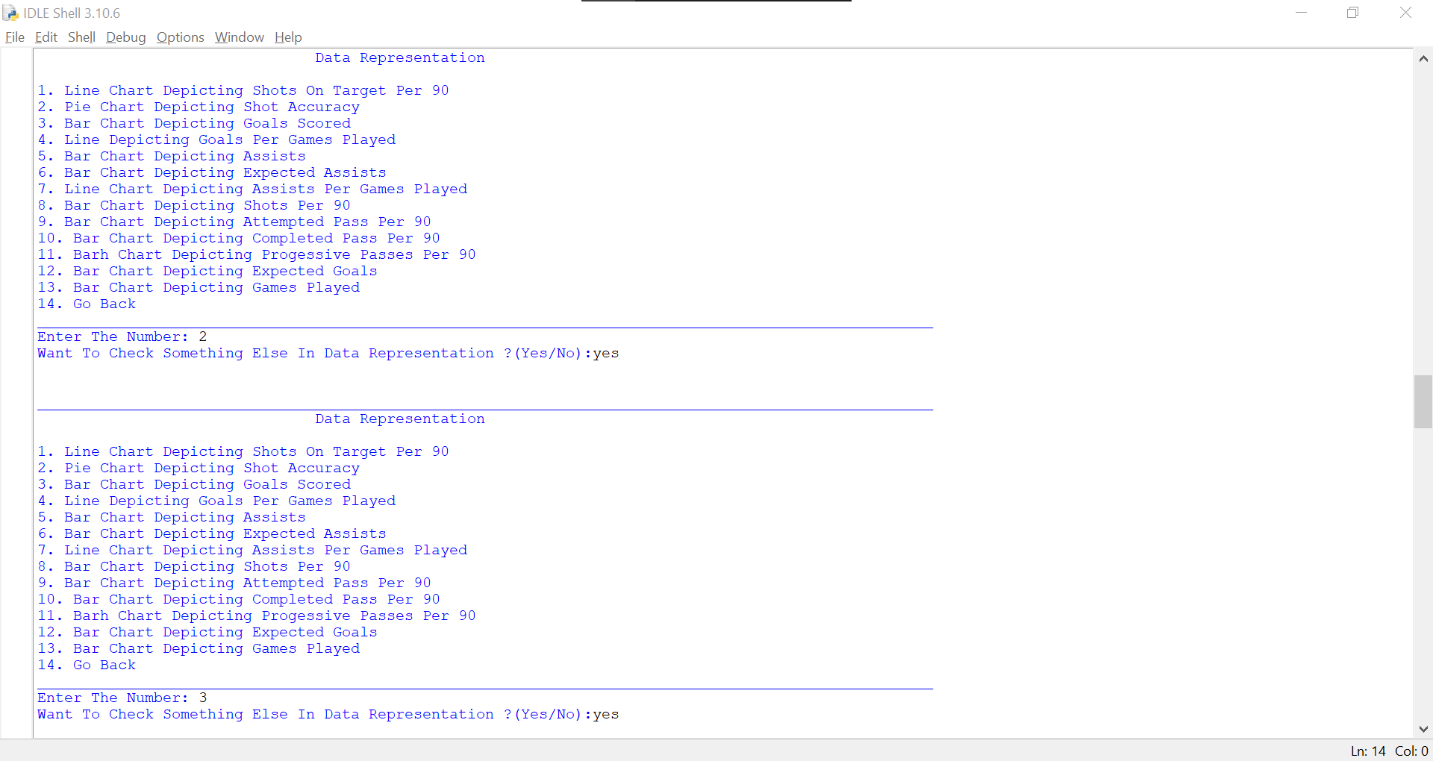

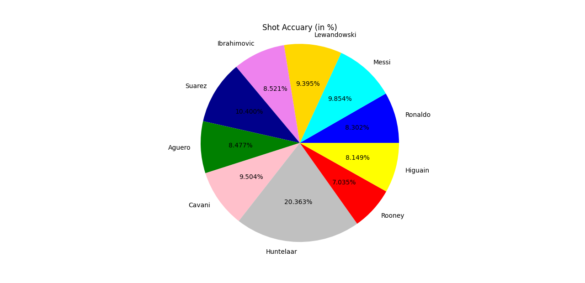

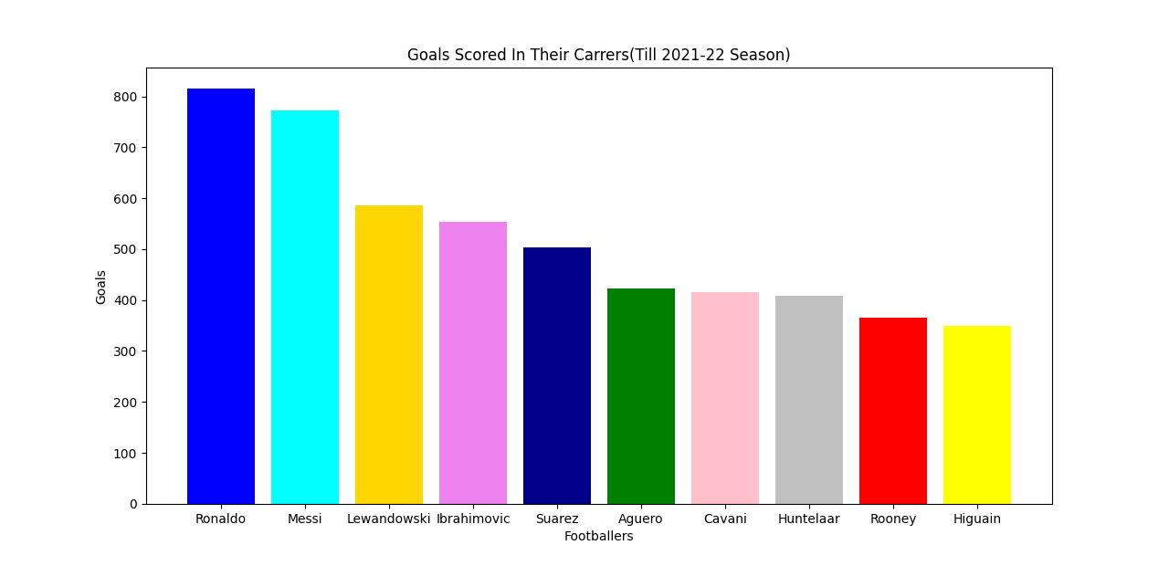

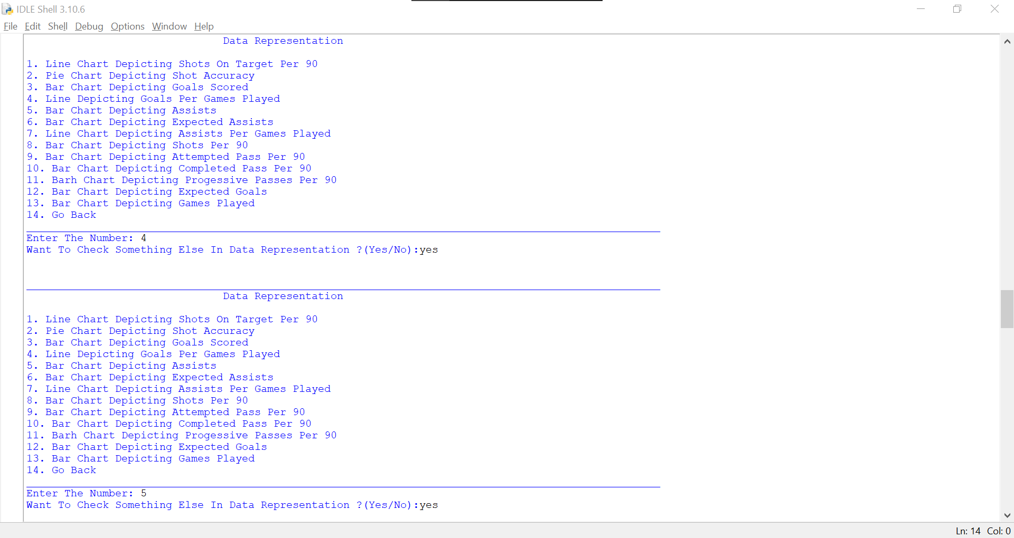

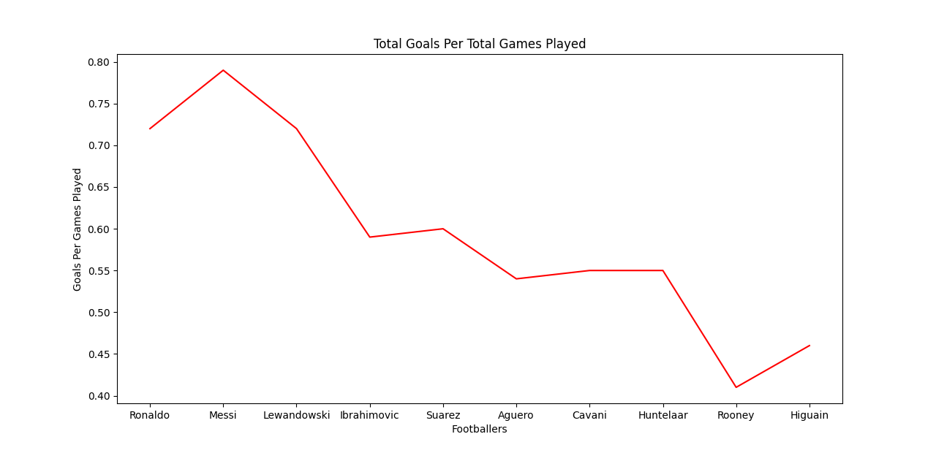

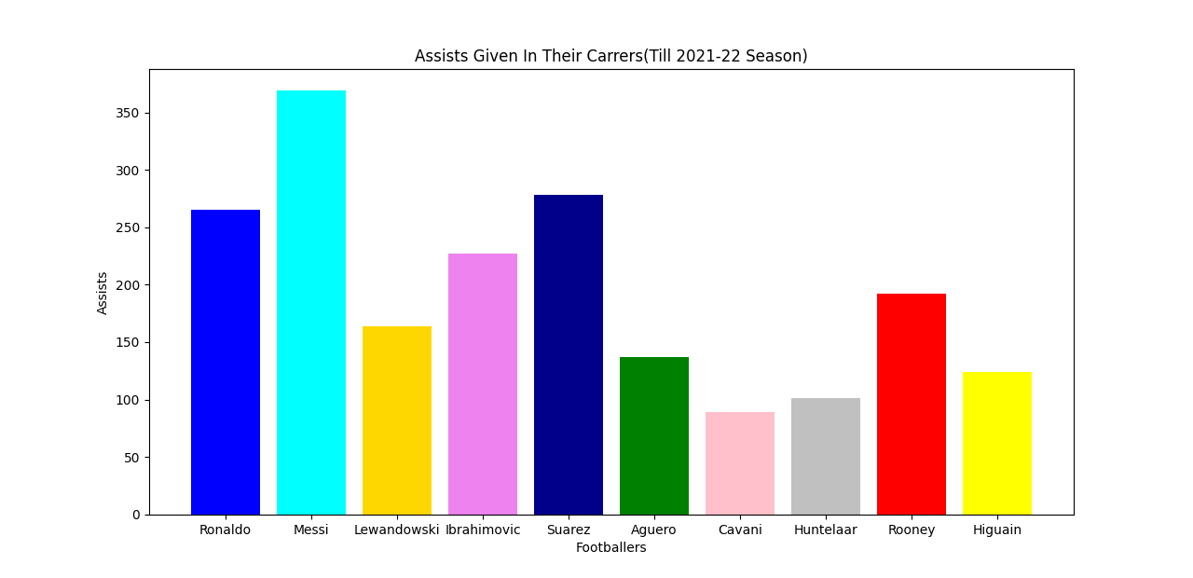

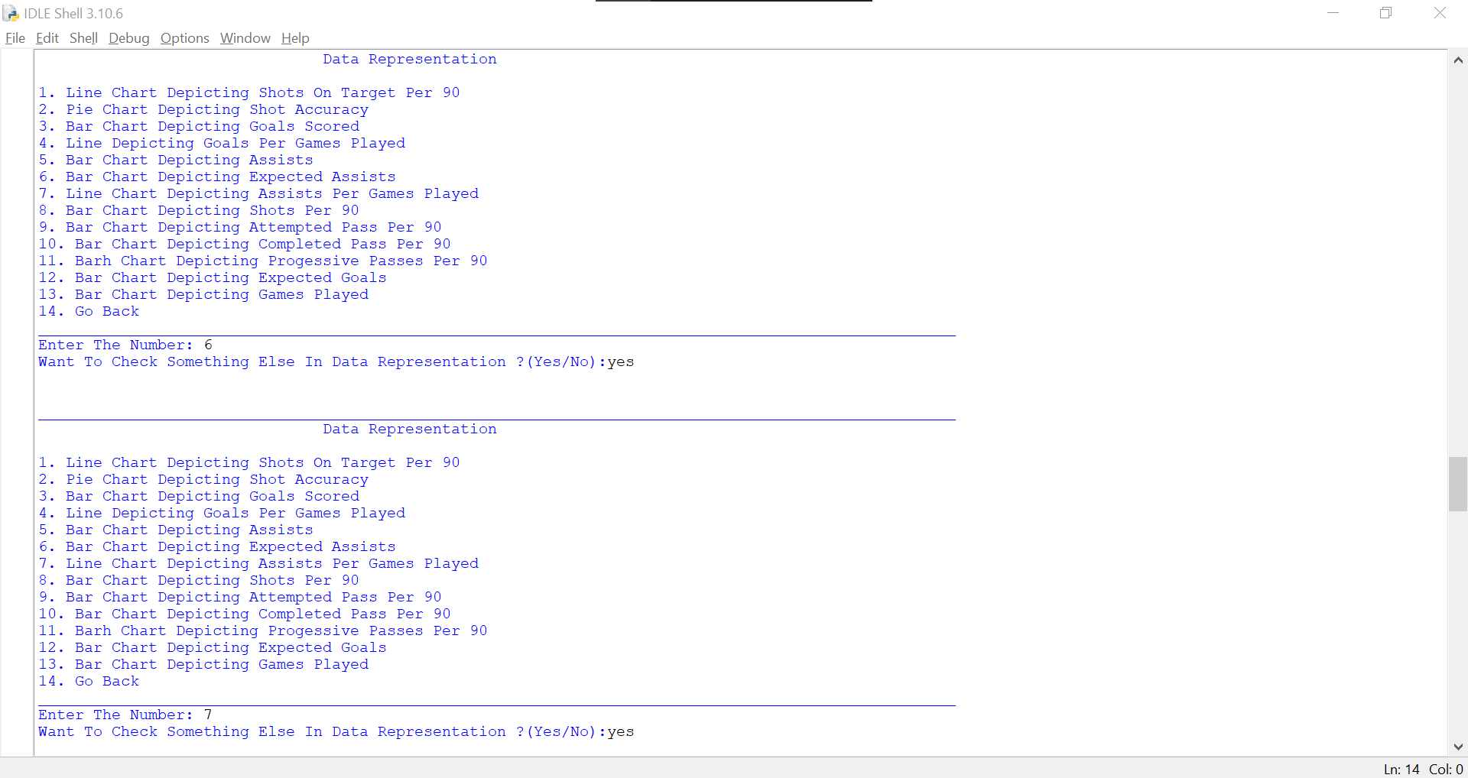

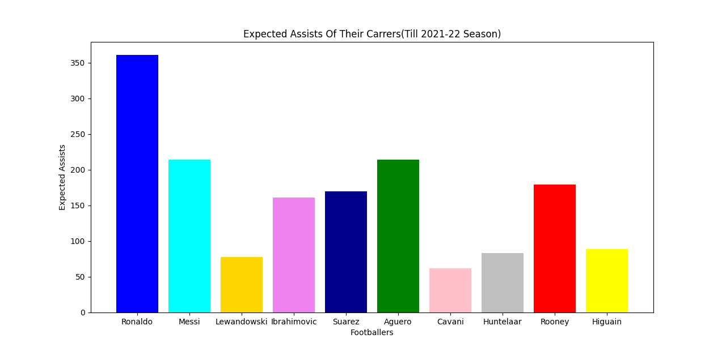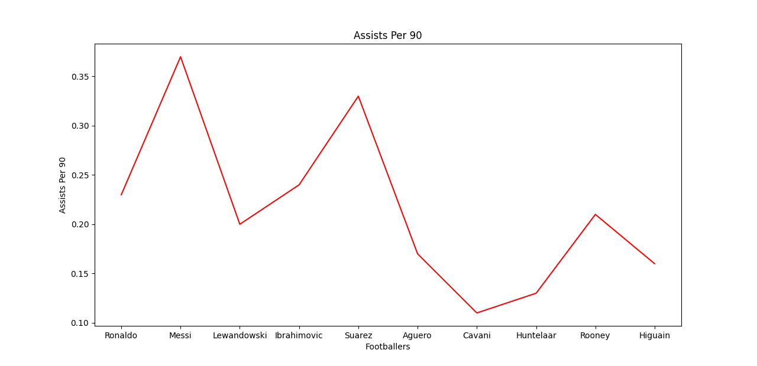

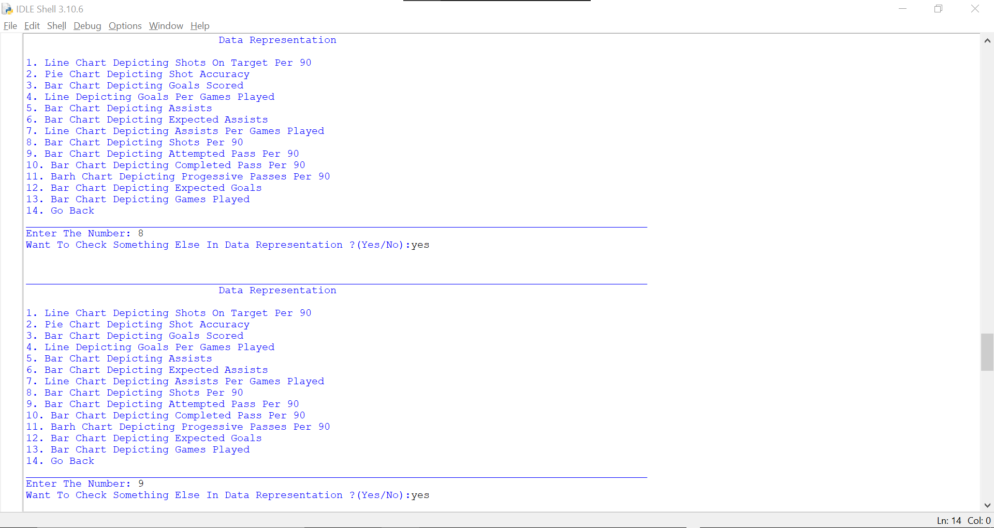

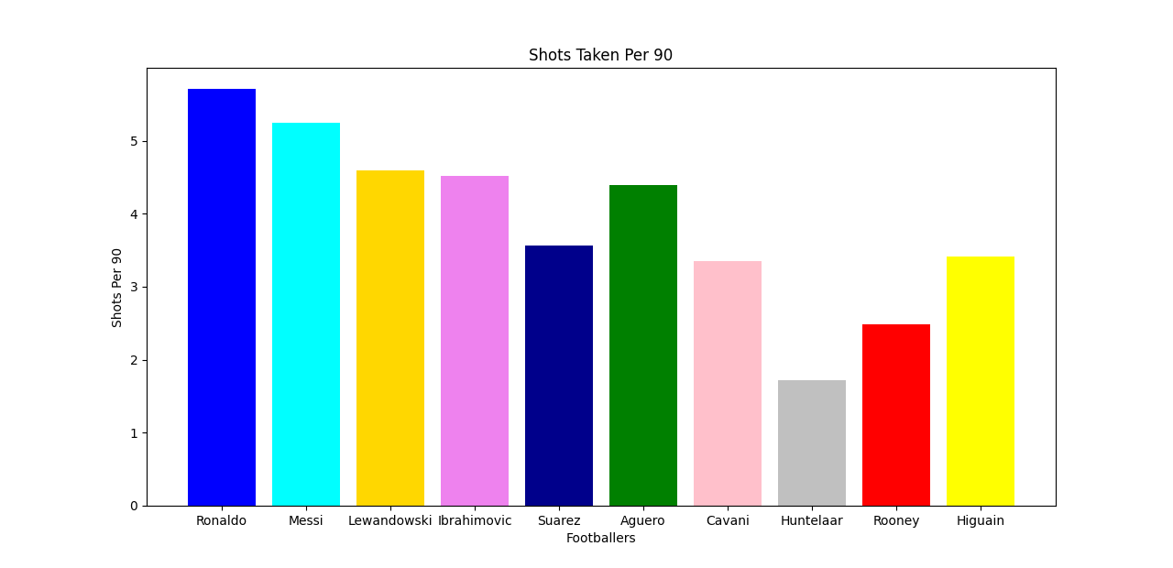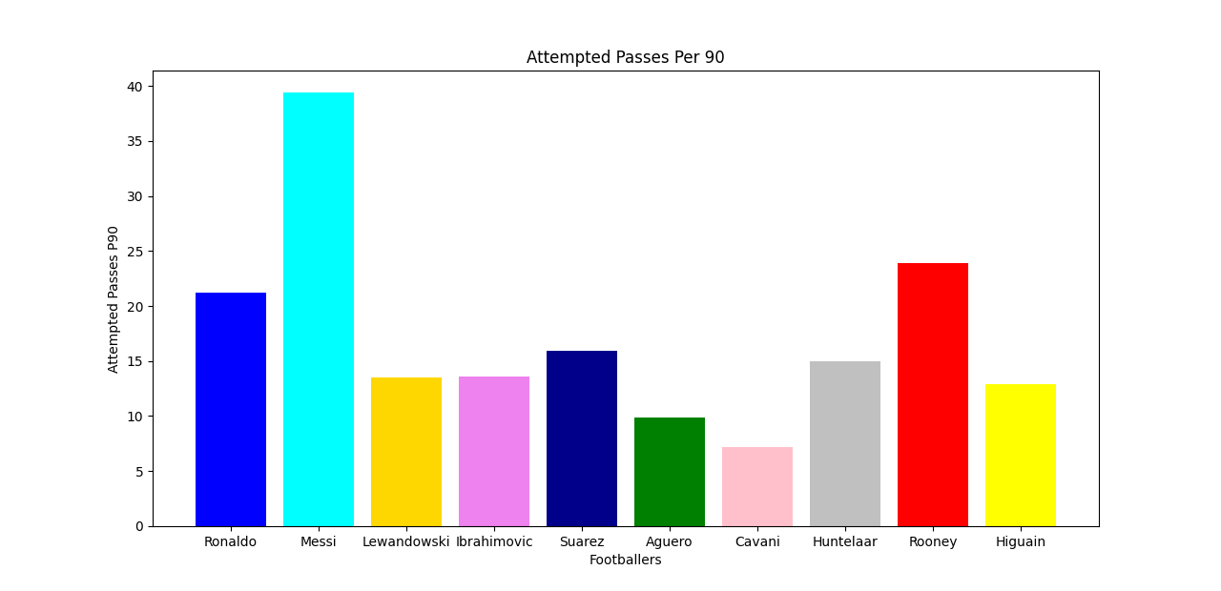

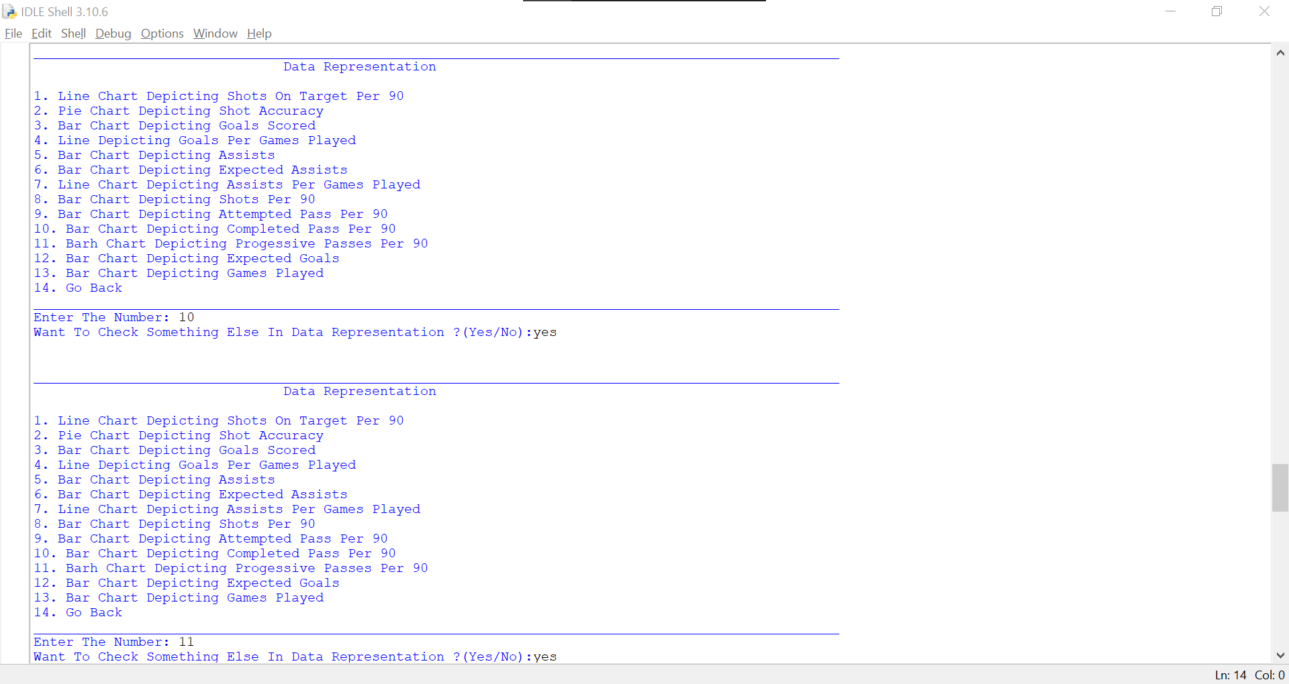

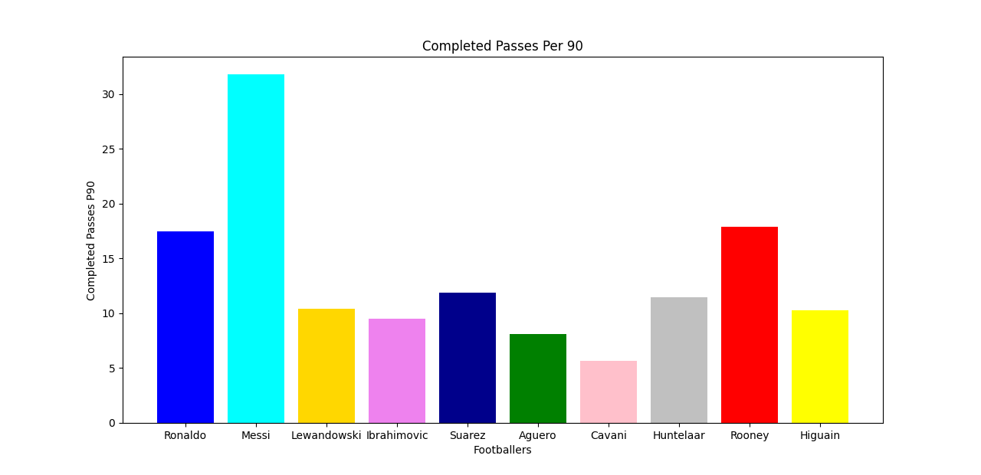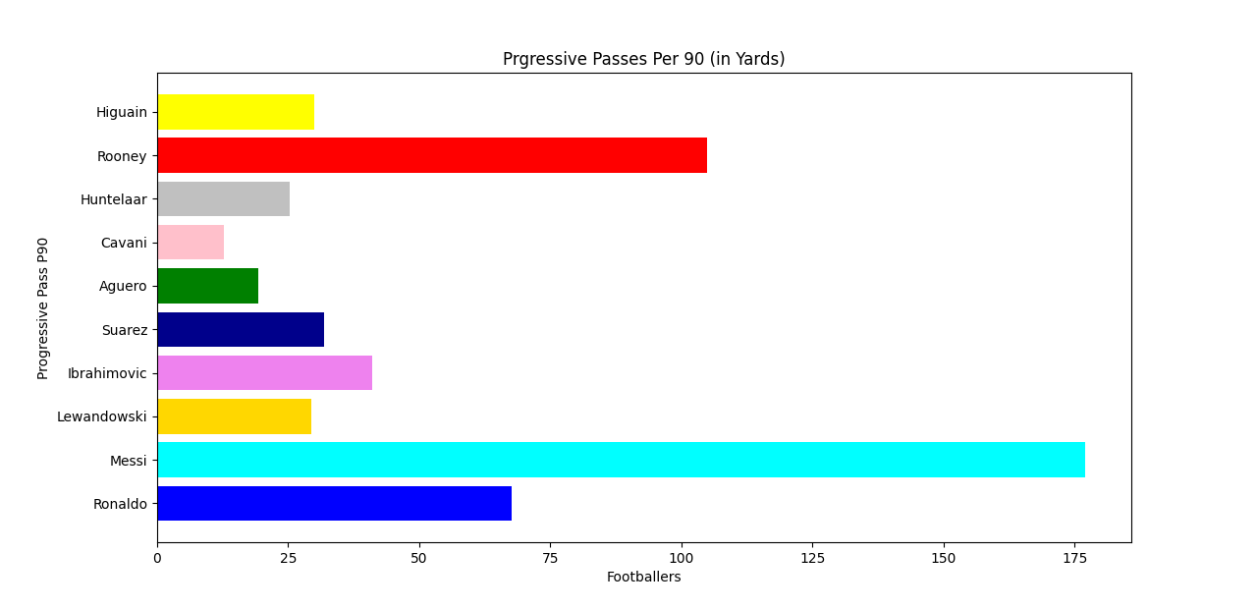

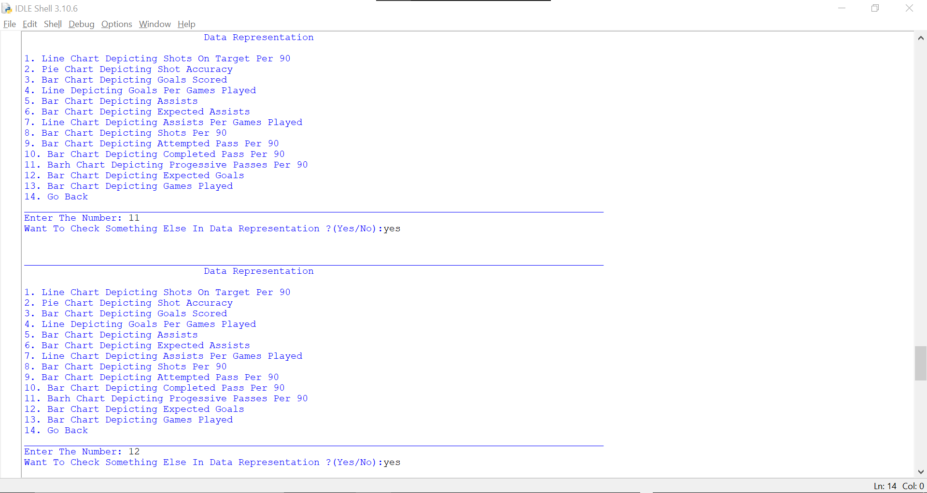

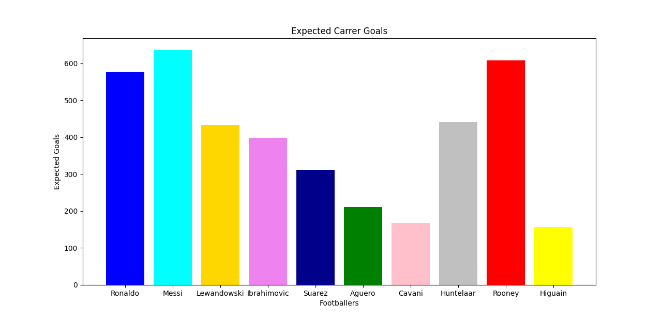

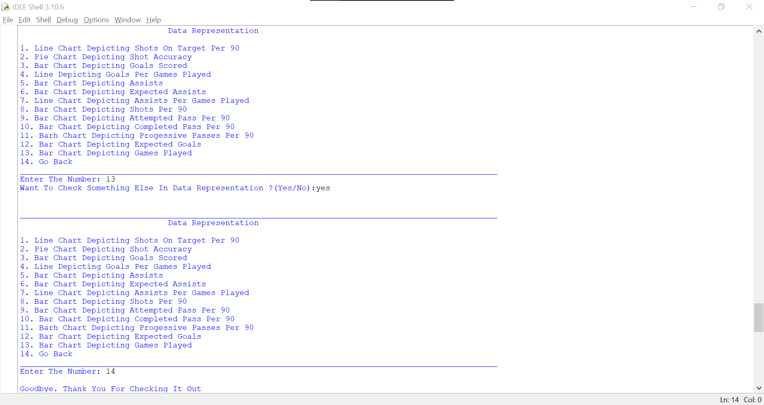

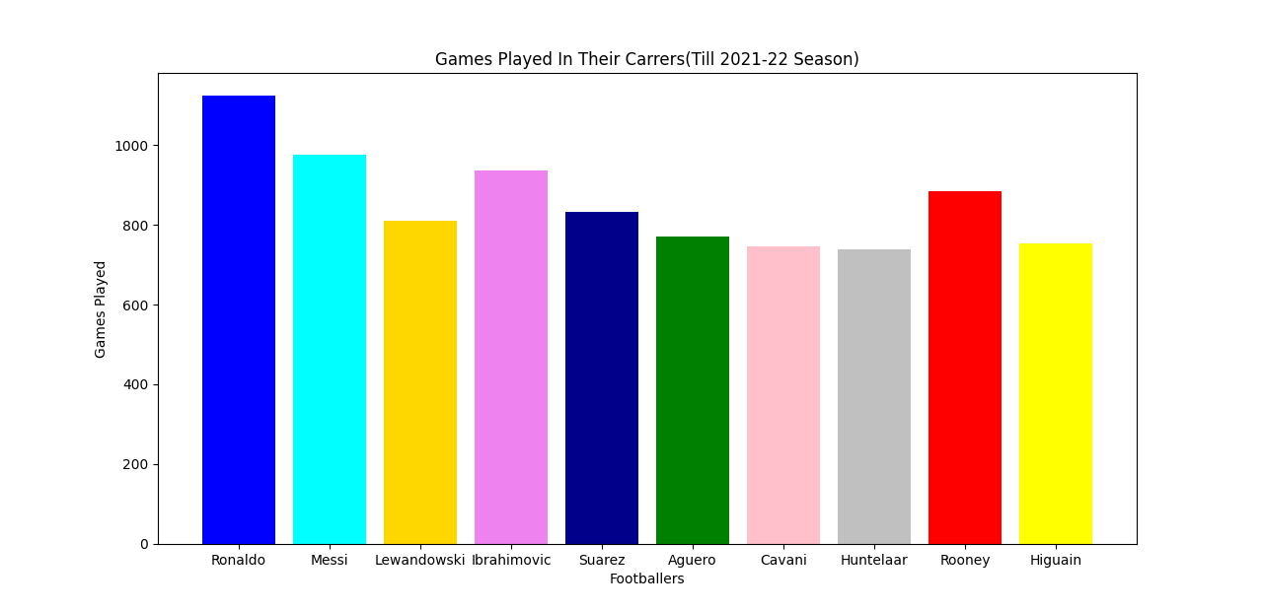

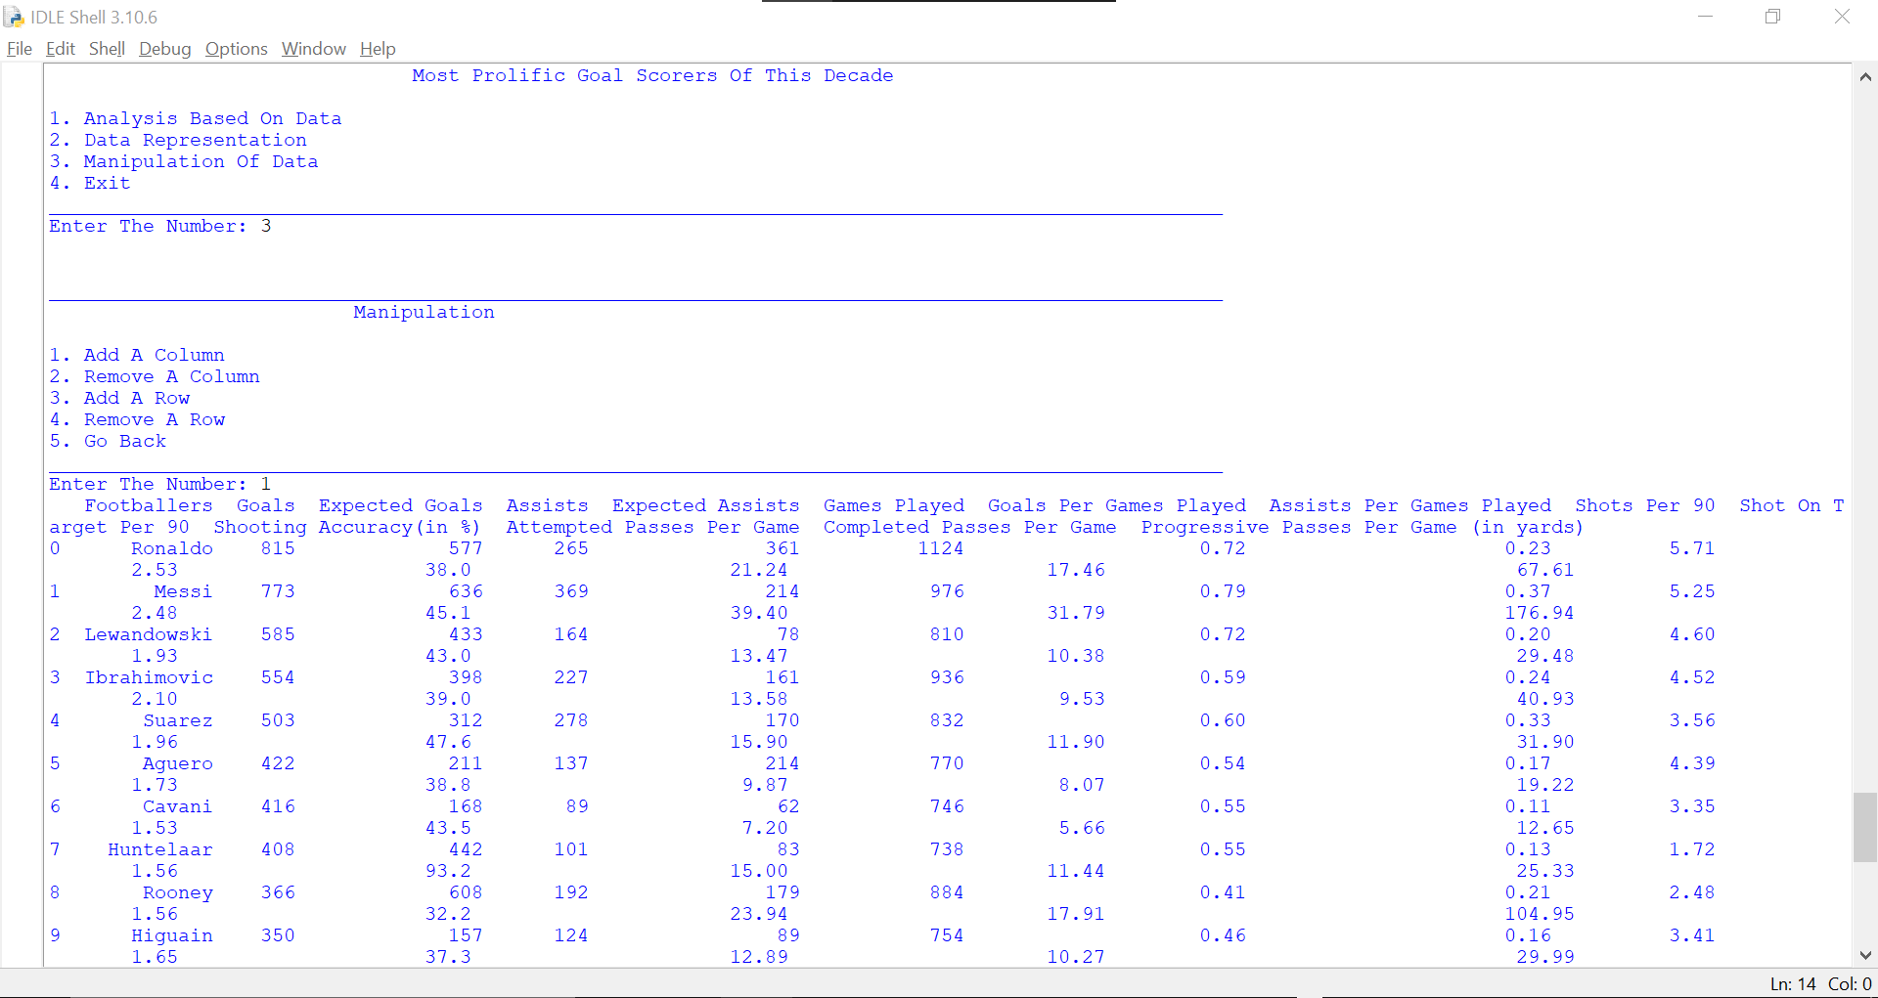

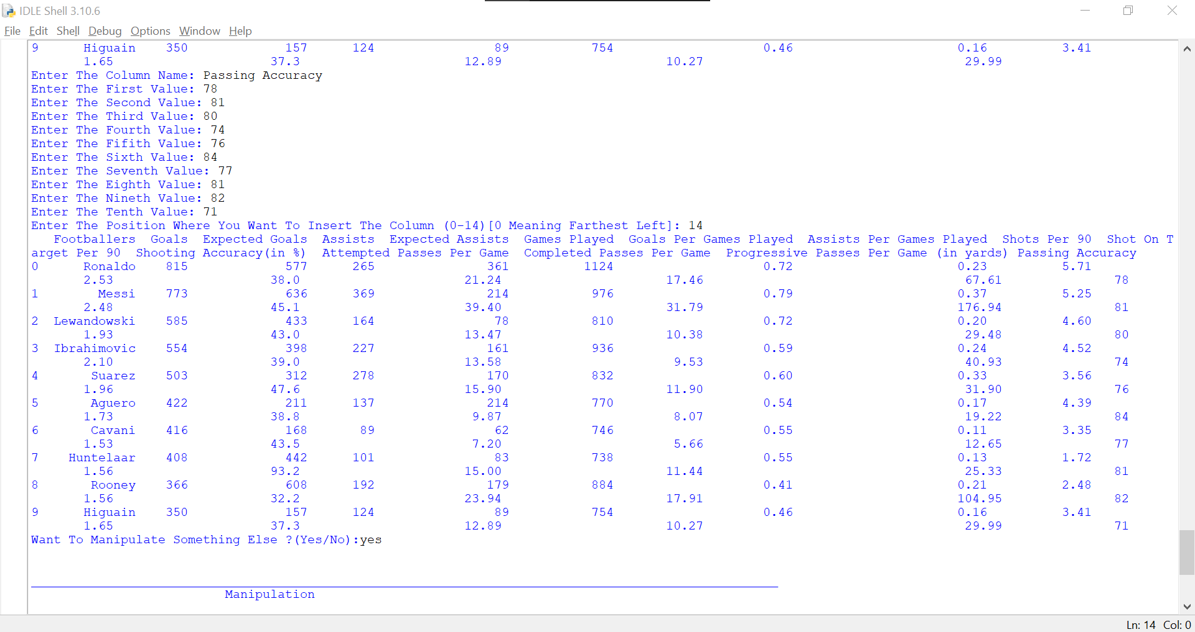

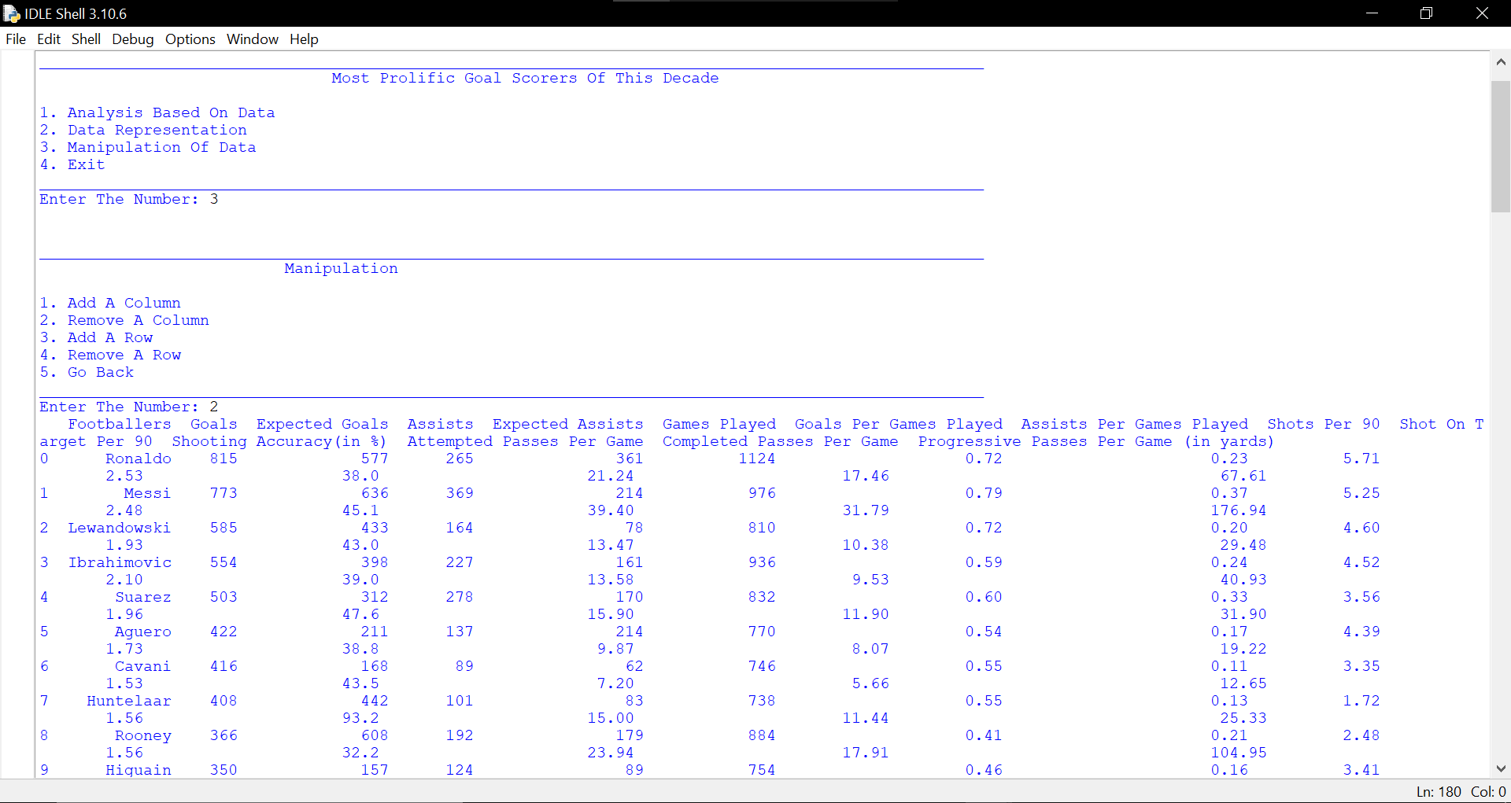

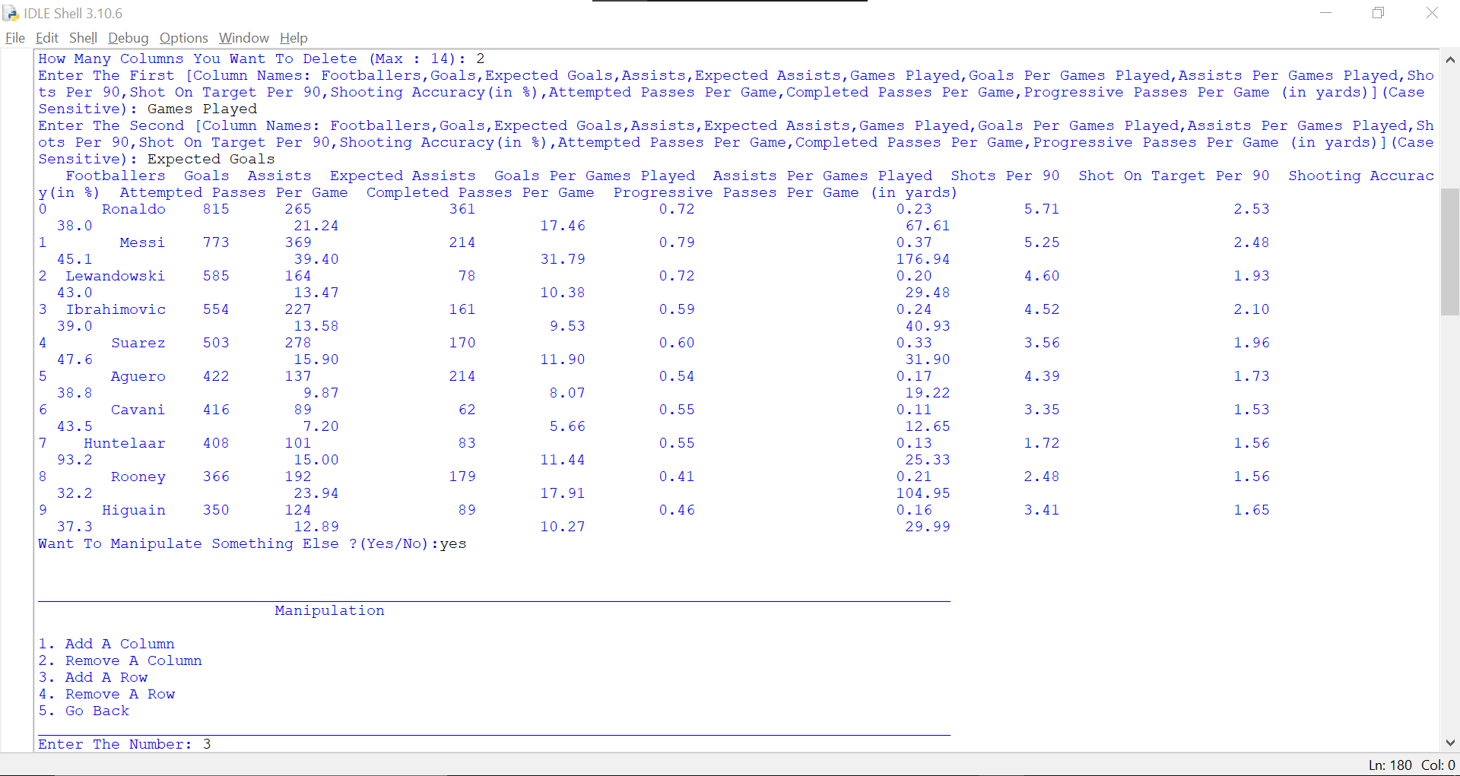

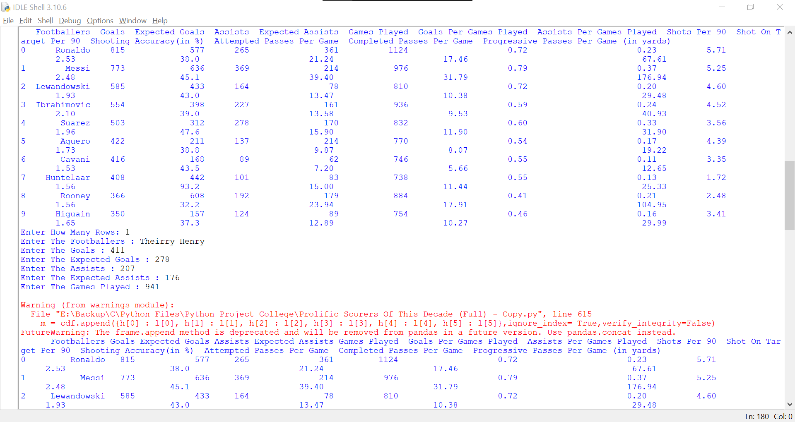

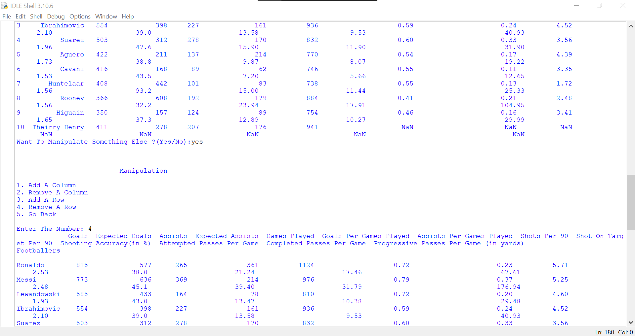

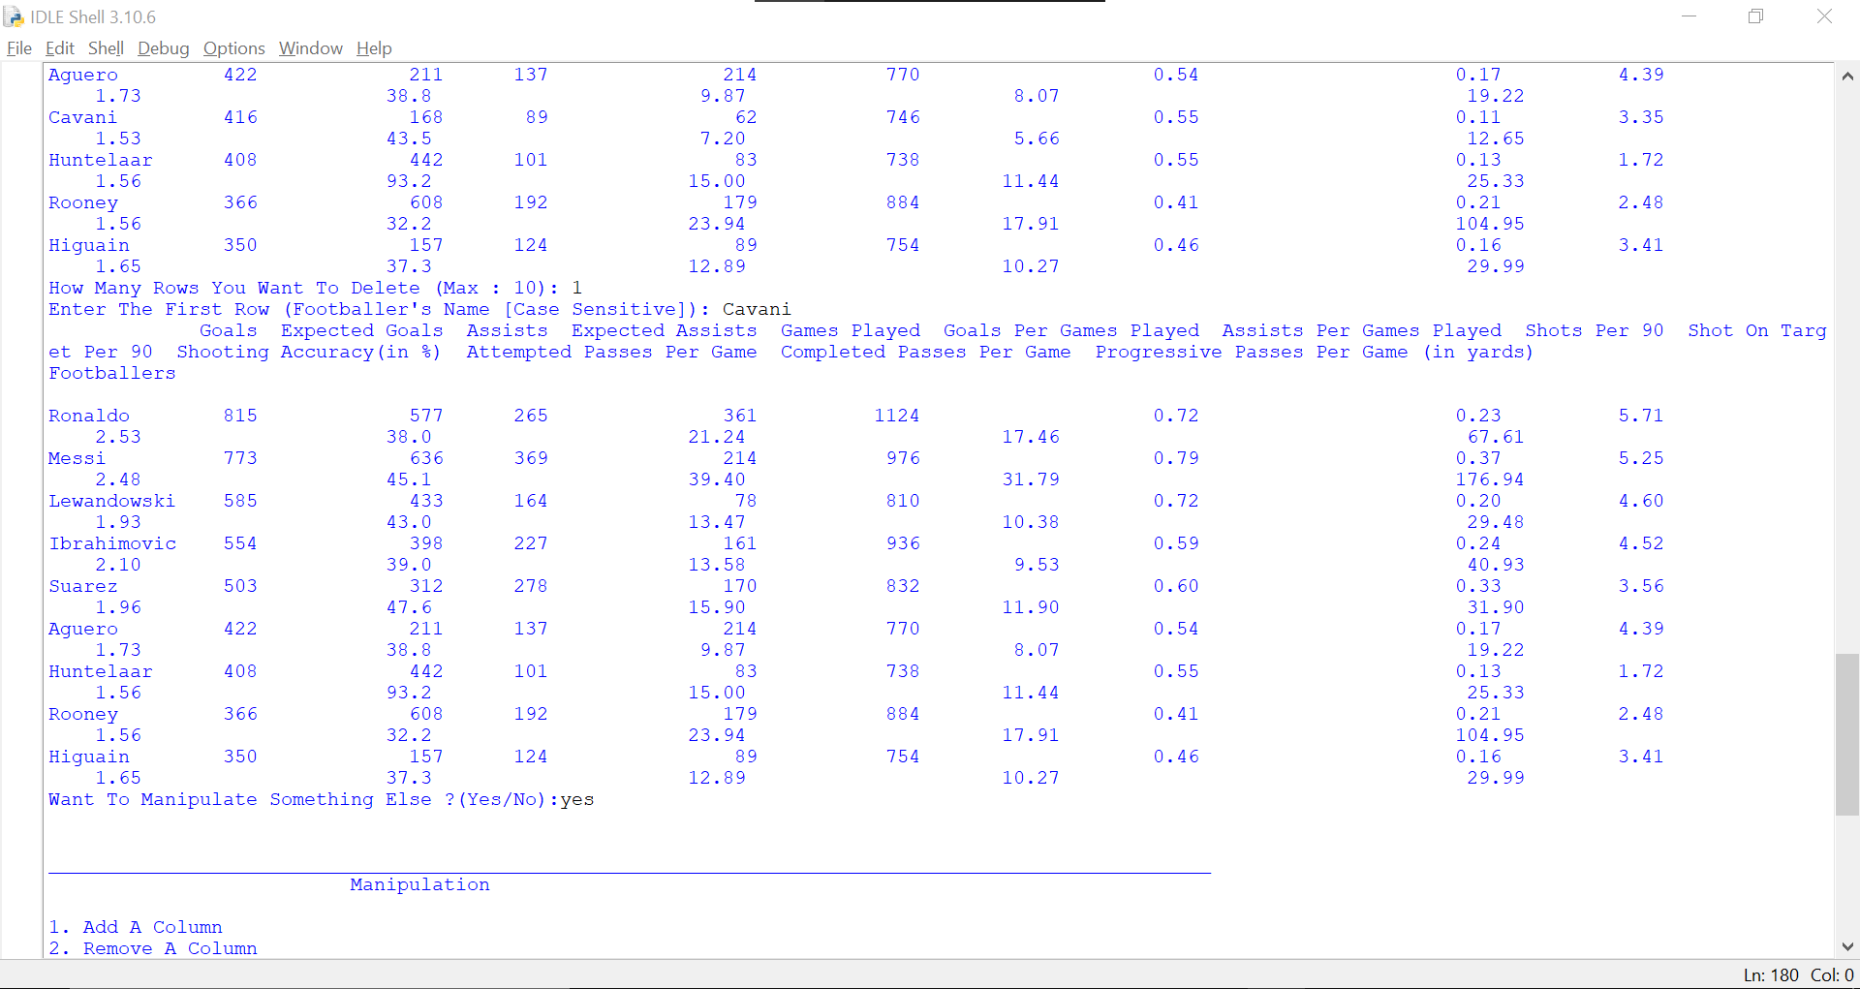

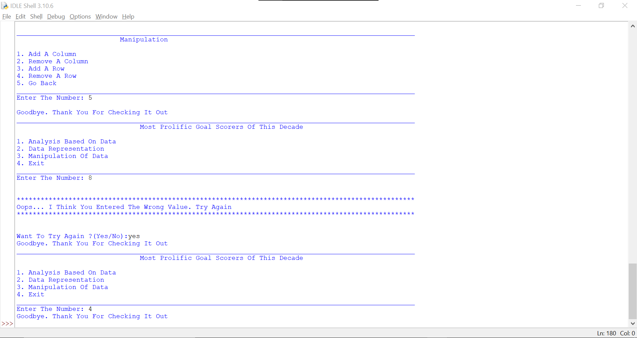

Conclusion :

The project helps to give a glimpse of sport analysts and also tells us about the greatest goalscorers and why they scored so many goals.

References :

* **Software Used :** Python Programming Language
* **References :** Informatics Practices Textbook, [www.transfermarkt.co.in/](http://www.transfermarkt.co.in/) , [www.nei.nih.gov/learn-about-eye-health/eye-conditions-and-diseases/color-blindness/types-color-blindness](http://www.nei.nih.gov/learn-about-eye-health/eye-conditions-and-diseases/color-blindness/types-color-blindness), https://fbref.com/en/

1. <https://en.wikipedia.org/wiki/Quiz>Our aim is to develop an application for the users in which a user can attempt any number of

quizzes related to his/her choice.”